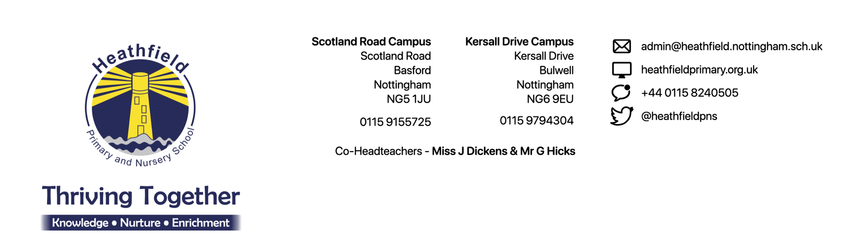

Thursday 11th January 2024

Dear Parents/Carers,

We are thrilled to be able to share with you the final report following our Ofsted inspection on the 5th and 6th December 2023, you can read the full report by clicking on this link https://shorturl.at/xCHV0. Over the two days, we had four inspectors visit each class, speak to almost all school staff, a large majority of the children, our governors and parents/carers. The thorough inspection allowed us to showcase what we do, working towards our aim of ‘Thriving Together’.

The report only captures the headlines from the vast amount of positive evidence that the inspectors captured over the two days. We were fortunate to be able to sit in several feedback sessions throughout the inspection period and were very proud to hear what the inspectors were seeing and hearing whilst in our school. Click on this link to read some of this feedback https://shorturl.at/jzNW0.

The comments that inspectors received from parents/carers, at both campuses, was also overwhelmingly positive. We are pleased that the report makes reference to the consistency in the offer our children receive no matter which campus they attend. This is something we work hard on every day and will continue to do so for your children.

We are both very proud of our whole school community and are so pleased that inspectors were able to get a true reflection of what goes on at Heathfield every day. We are both excited to build on this report and continue to try to make Heathfield an even more fantastic place for children to come and learn.

We would also like to share with you a letter from Julie Nicholson, our Chair of Governors, you can access it by clicking on this link https://shorturl.at/eryE1.

Yours Sincerely,
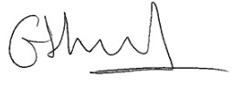
Miss Dickens and Mr Hicks – Co-Head Teachers

