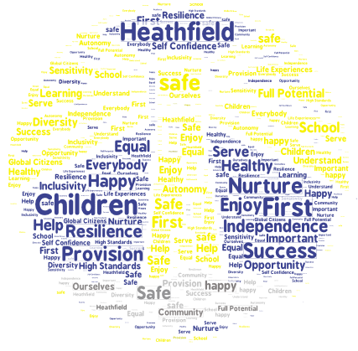

Keeping Heathfield Safe

A guide for children and parents

Approved by School Council Members Summer 2023

At Heathfield all adults work to keep the children safe.
How do they do this?
The staff ensure that:
- all planned activities are safe
- equipment is checked
- all visitors have been signed in at the office
- the Safeguarding Policy is followed
- school safety rules are followed
- gates are locked during the day
- the school is clean and tidy
- the curriculum is well thought out
- there are opportunities for people to talk about how they are feeling

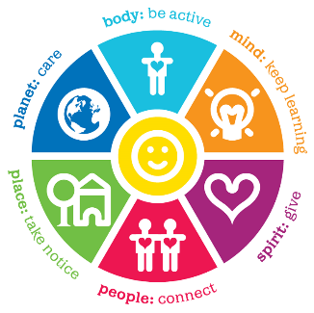
What is Safeguarding?
Safeguarding means staff will do their best to:
- protect you from harm
- make sure your wellbeing is important

Safeguarding is EVERYONE’S responsibility at Heathfield so you can help too!
- Tell an adult if you are not ok for any reason because of something happening at school or at home.
- Follow the school rules to keep you and others safe.
- Be friendly and kind to everyone.
What are you worried about?
Falling out with friends
Being hurt by someone
Being collected late from school
Being left home alone
Being in a new class with a new teacher
Unhappy in class
Worried about someone else
Being picked on or feeling like I have no friends
Getting nasty messages on my phone
Being asked to do stuff online
My work is too hard
Missing a meal at home
Getting to school late
Someone is being unkind
Moving school
Things happening at home

Adults argue at home

Can it be a secret?
Heathfield staff do not want anyone to keep secrets that make you feel bad. Sometimes it is difficult to talk about something but if you want things to stop or get better it is often best to talk about it with friends, family members or adults in school.
If you are worried about something and you tell an adult in school, they may need to let one of the safeguarding leaders know so we can make sure we are keeping you safe.
Sometimes we might speak to parents, sometimes we might speak to other children, sometimes we might ring for advice from the Children and Families department at the council because they can help school to make the right choices.

Who can you speak to in school?
Being touched and feeling uncomfortable
You can speak to any member of staff who you trust.
The following members of staff have had special training to make sure they know how best to support children, staff and families if there is ever a problem or a worry which needs sharing.
Miss Dickens is our Designated Safeguarding Leader (DSL) and is responsible for making sure all adults understand and are following our safeguarding policy.
Mrs Dyer is our Safeguarding Officer – she works closely with Miss Dickens and parents/carers to make sure that all children are safe.
Miss Papp, Miss Parmiter and Mrs Baker are our Learning Mentors – they have time to talk with children about any worries you have. They also speak to parents/carers if they need help or advice.
Mr Battison is our Deputy Headteacher and oversees the Pastoral team in school. He is here to support with behaviour, attendance and safeguarding.
- Claire and Karen from CASY are our school counsellors who, with parent permission, can offer sessions to children who need an extra place to talk.
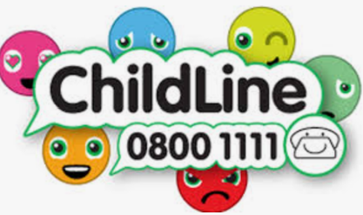
If you are still worried you can:
Ring Childline – they have people on the phone called counsellors, who can listen to you and offer ideas to help you. www.childline.org.uk
Advice for parents on a range of topics can also be found on www.nspcc.org.uk
Visit our school website for our Safeguarding and Child Protection policy. www.heathfieldprimary.org.uk

