**Heathfield Primary School**

30th aPRIL 2021 kERSALL DRIVE CAMPUS

**Attendance for the whole school for last week was 95.7%**

If your child is too poorly to attend please let us know on the first day of absence on 0115 9794304

All children should attend school everyday

|  |  |  |  |  |  |  |  |  |  |
| --- | --- | --- | --- | --- | --- | --- | --- | --- | --- |
| **Jellyfish AM   91.9%** | **Jellyfish PM  98.6%** | | | **Jellyfish FT   100%** | | **Turtles   96.3%** | | | **Octopus  95.1%** |
| **Hedgehogs  97.2%** | | **Owls   89.7%** | | | **Squirrels 96.7%** | | | **Rabbits  95.3%** | |
| **Peacocks   99.2%** | | **Eagles 95.4%** | | | **Pelicans   92.4%** | | | **Falcons  97.6%** | |
| **Panthers 95.7%** | | | **Pumas 96.2%** | | | | **Leopards   96.2%** | | |

**REMINDER:** Monday 3rd April is a **Bank Holiday** therefore school will be closed on that day. We will be open as normal on Tuesday 4th May.



**Friday Afternoon Rainbow Club:** Please use this link to sign up your child/children to Rainbow Club on **Friday 7th May: https://bit.ly/3tePnv3**

This club is only open to single parent/carer working families or families where both parent/carers work on a Friday afternoon. Evidence will be required if it has not already been given.  **This form must be completed every week by 2pm on Thursday afternoon if a place is required.**  **All Rainbow Club children should be collected at 3:30pm unless attending the afterschool club.**

**Height and weight checks for Turtles, Octopus and all Year 6 children:**  Every year the height and weight of Reception and Year 6 children in schools in England is measured. This is called the National Child Measurement Programme (NCMP). Trained health staff from Nottingham CityCare Partnership carry out the measurements and they will be coming into school to do this on **Wednesday 19th May**. Children are measured in a private space away from other children and will be fully clothed, only taking off their shoes and coats.

All children in Turtles, Octopus and all Year 6 children should have received a letter with further details on. If you have not yet received one please come to the school office to collect a letter as soon as possible. If you are happy for your child to be measured, you do not need to do anything. If you do not want your child to be measured, please tell the school office no later than Friday 14th May**.** Children will not be made to take part on the day if they do not want to. Further information about the National Child Measurement Programme can be found at:

<https://www.nhs.uk/live-well/healthy-weight/national-child-measurement-programme>

**Calling ex-pupils of Heathfield Primary School:** It is all too easy to lose touch with our primary school friends. Since the school opened in 1913 many thousands of children have attended the school making it a truly vast alumni community. With this in mind, there is a huge wealth of knowledge, experiences and expertise that would be great to share with our current Heathfield children so, we would like to set up a Heathfield Alumni. Hopefully, we can all enjoy the benefits this will bring.

You might like to:-

* Come into school to talk about your chosen path and inspire and encourage our children – saying “When I was a pupil at Heathfield, I sat there and now I’m . . . “ is a very powerful opening line!
* receive termly updates
* attend school open events
* attend alumni events and meet up with former classmates
* visit the school for a ‘tour’

We hope that we can develop the Heathfield Alumni group; it will be great to see where it takes us over the coming years. If this is something you would be interested in, please contact Mr Battison [leopards@heathfield.nottingham.sch.uk](mailto:leopards@heathfield.nottingham.sch.uk) and he will be in contact to discuss further.

**Some happy news!** Last month Miss Hampson and Kieran (site manager) welcomed a baby boy to their family and to our Heathfield family and last week Miss Thompson (Rabbits teacher) got married! She will be known as Mrs Downer from now on. Congratulations from all of us ☺

**NEW Afterschool Clubs are coming!** Now ‘hopefully’ things are beginning to return to some sort of normal we would like to begin some afterschool clubs for the children to learn new skills and have fun. The Teachers and Teaching Assistants are finalising dates when these can start but there should be something for each year group coming very soon.

**KS1 Nature Fun Club:** Mrs Downer and Miss Parmiter would like to start a Nature Fun club for children in Hedgehogs, Owls, Squirrels and Rabbits on Thursdays from 3:30pm-4:15pm starting on Thursday 6th May. This club will be exploring the outdoors and getting involved in the nature garden and Edible Playground. Children will need to wear a coat or jumper as it is still quite chilly outside at the moment.

**Year 3 and 4 Choir:** Miss Hunt and Miss Tunstall will be starting a Year 3 and 4 Choir after school club on a Thursday from 3:30pm-4:15pm starting on Thursday 6th May.

If your child would like to take part in either of these clubs mentioned above please complete and return the reply slip on this form as soon as possible. Thank you.

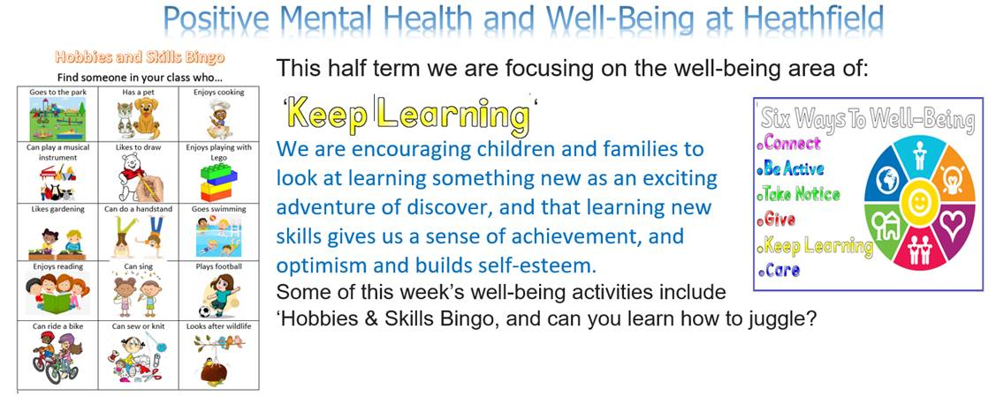

**Self-Isolation Guidance:** A reminder to all parents/carers that should anyone in your house have Covid-19 symptoms or have received a positive test result, **all members of the household should self-isolate for 10 days and not attend school.**

Please let school know if anyone in your household is self-isolating or has had a positive Covid test result using our out of hours email [covidreporting@heathfield.nottingham.sch.uk](mailto:covidreporting@heathfield.nottingham.sch.uk)

**Home Testing:** From 1 March 2021 all adults in households with school and college age children **without symptoms** can now access regular rapid coronavirus (COVID-19) testing (Lateral Flow Device Tests).

Please do not share kits with your child if they are under 11. If your child has covid symptoms you should immediately obtain a PCR test via this website <https://www.gov.uk/get-coronavirus-test>. If your child has covid symptoms, a negative LFD test will not allow them to return to school early.

You can get twice-weekly test via one of four ways; note these kits are not available from your child’s school. Secondary school and college students aged 11 and above will continue to access their own regular rapid tests directly through their school or college.

|  |
| --- |
| **Via Your employer**  Your workplace may offer rapid lateral flow testing to you. Contact your employer to find out more. |
| **C:\Users\joanne.simons\AppData\Local\Microsoft\Windows\INetCache\Content.MSO\829ED40A.tmpTesting at a local Community Test Site**  Testing at these sites is assisted, which means you will swab yourself under the supervision of a trained operator. You do not need to make an appointment.  They are currently at three locations in Nottingham:  Further details are available here:  [www.nottinghamcity.gov.uk/asymptomatictesting](http://www.nottinghamcity.gov.uk/asymptomatictesting) |
| **Collect test kits**  You can collect 2 packs of home test kits at a local collection point. Each pack contains 7 tests. Anyone 18 or over can collect. You do not need to make an appointment.  Do not visit a collection point outside opening hours, as it may be used to test people with coronavirus symptoms outside these times.  Details of how to find your nearest test collection site are here:  <https://find-covid-19-rapid-test-sites.maps.test-and-trace.nhs.uk/> |
| **Order home test kits online**  If you cannot get tested at your workplace or are unable to go to a test site or collect test kits, you can order a home test kit online.   Do not order online if you can get a test through other methods. This frees up home delivery for those who need it most. [Order rapid lateral flow home test kits](https://www.gov.uk/order-coronavirus-rapid-lateral-flow-tests) |

**What twice-weekly testing involves.** You will be asked to:

* take a test twice a week (every 3 or 4 days apart)
* report every result to NHS Test and Trace on the same day you take the test
* [Report your test result online](https://www.gov.uk/report-covid19-result) or by calling 119.

If anyone tests positive or gets coronavirus symptoms, they should tell the school and:

* self-isolate immediately
* get a PCR test to confirm the result via <https://www.gov.uk/get-coronavirus-test>
* follow the [stay at home guidance for households with possible coronavirus infection](https://www.gov.uk/government/publications/covid-19-stay-at-home-guidance)

A negative result means the test did not find signs of coronavirus. But this does not guarantee you do not have coronavirus, so you should keep following all [coronavirus advice](https://www.gov.uk/government/publications/how-to-stop-the-spread-of-coronavirus-covid-19/how-to-stop-the-spread-of-coronavirus-covid-19) including:

* regular handwashing
* social distancing.

If you have any questions about this process contact NHS on 119, please do not contact the school.

--------------------------------------------------------------------------------------------------------------------------------------------------------

**After School Clubs** – starting Thursday 6th May 2021

I give permission for my child . . .  . . . . . . . . . . . . . . . . . . . . . . . . . . . . . . . . . . . . .   in class . . . . . .  . . . . . . . . . to take part in the following club.

     ☐ Thursday 3.30pm-4.15pm – KS1 Nature Fun Club (Hedgehogs, Owls, Squirrels and Rabbits)

☐ Thursday 3.30pm-4.15pm – Year 3 and 4 Choir (Peacocks, Eagles, Pelicans and Falcons)

Should we receive too many reply slips, we shall draw names out of a hat to ensure it is fair for all children.

Signed by Parent /Carer. . . . . . . . . . . . . . . . . . . . . . . . . . . . . . . . . . . . . . . . . . Date . . . . . . . . . . . . . . . . . . . . .

Collecting arrangements

☐ I will collect my child when the club has finished           ☐ My son/daughter is going to afterschool club