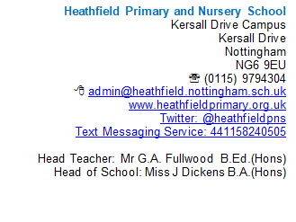

3rd January 2021

Dear Parents/Carers,

Please accept my apologies for this letter being sent so late on a Sunday, especially when it is the day before school should be reopening to pupils for the start of the Spring Term.
Following Trade Union guidance that was issued to its members yesterday, I have today been inundated with emails from staff declaring their unavailability to return to school tomorrow to continue to teach whole classes.
Therefore, I have been left with no alternative but to close both Scotland Road and Kersall Drive campuses for tomorrow (Monday 4th) and Tuesday 5th January to the very large majority of pupils. However, work will be provided remotely by class teachers to support your child with their continued learning with immediate effect from tomorrow morning.

If, during March to July your child was eligible for our key worker and vulnerable children provision and your circumstances have not changed, then they are expected to attend school and their usual campus tomorrow as normal, as they will be taught in small groups. (Breakfast and After School Club will remain open to these children only at the usual times).

We will then use these next 2 days to gain a clearer view on the full availability of all staff and will write to you in due course with our arrangements for the remainder of the week and moving forward into the term.

Once again, please accept my apologies for this late notice and rest assured we will do our utmost to return to provision for all pupils in school as soon as possible.

Yours sincerely,

Gary Fullwood
Executive Head Teacher

