Home Learning App

Microsoft Teams

Over the coming weeks we will begin to use Microsoft Teams to communicate and share home learning with classes.

This will be an easier way for us to share home learning tasks and lessons with your child and for them to submit their work to us.

To get started, we need to make sure that all children have access to Microsoft Teams, either via the Microsoft Teams app or website where they will be able to access their home learning in the future.

Individual usernames and passwords will be sent to parents and carers via text.
In preparation for this, please download the app on the device your child will be using for their home learning using the links below or by searching for ‘Microsoft Teams’ in the app store:

Laptop / PC | https://www.microsoft.com/en-gb/microsoft-365/microsoft-teams/download-app
 | https://apps.apple.com/gb/app/microsoft-teams/id1113153706
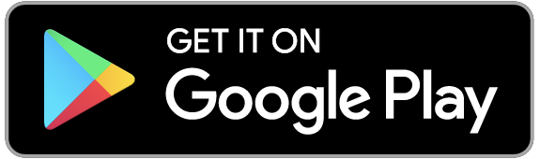 | https://play.google.com/store/apps/details?id=com.microsoft.teams&hl=en_GB

If you are unable to download any of the apps, you are able to access Microsoft Teams by logging onto this website:

www.Microsoft.com/teams

If your child does not have access to a phone, tablet, laptop or desktop computer - please let your child’s teacher know by using the class email address below.

lions@heathfield.nottingham.sch.uk
jaguars@heathfield.nottingham.sch.uk
tigers@heathfield.nottingham.sch.uk

