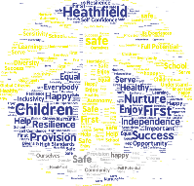
September Full Reopening of School – Staff Protocols
Risk Assessment headlines for staff:
- Preventing symptomatic persons attending work:
  - Staff and pupils who report the following symptoms remain at home for 7 days. Their household members must remain at home for 14 days:
  - a high temperature – this means you feel hot to touch on your chest or back (you do not need to measure your temperature)
  - a new, continuous cough – this means coughing a lot for more than an hour, or 3 or more coughing episodes in 24 hours (if you usually have a cough, it may be worse than usual)
  - A loss or change to your sense of smell or taste – this means you ‘ve noticed you cannot smell or taste anything, or things smell or taste different to normal

- Illness:
  - Designated area for any unwell person to remain until collected will be located:
- SR Groups room
- KD large accessible toilet near F1
- The member of staff supervising the ill person must wear full PPE (gloves, fluid face mask, apron, eye protection)
- Once the room is vacated, site staff should be informed to thoroughly clean the room
- Staff who have helped do not need to go home unless you develop symptoms

- Testing for Covid19:
  - All staff who are attending a school will have access to a test if they display symptoms of coronavirus, they are encouraged to get tested in this scenario.
  - Where the staff member tests negative, they can return to their setting and the fellow household members can end their self-isolation.
  - Where the staff member tests positive, the rest of their class or group are sent home and advised to self-isolate for 14 days. The other household members of that wider class or group do not need to self-isolate unless the child, young person or staff member they live with in that group subsequently develops symptoms.

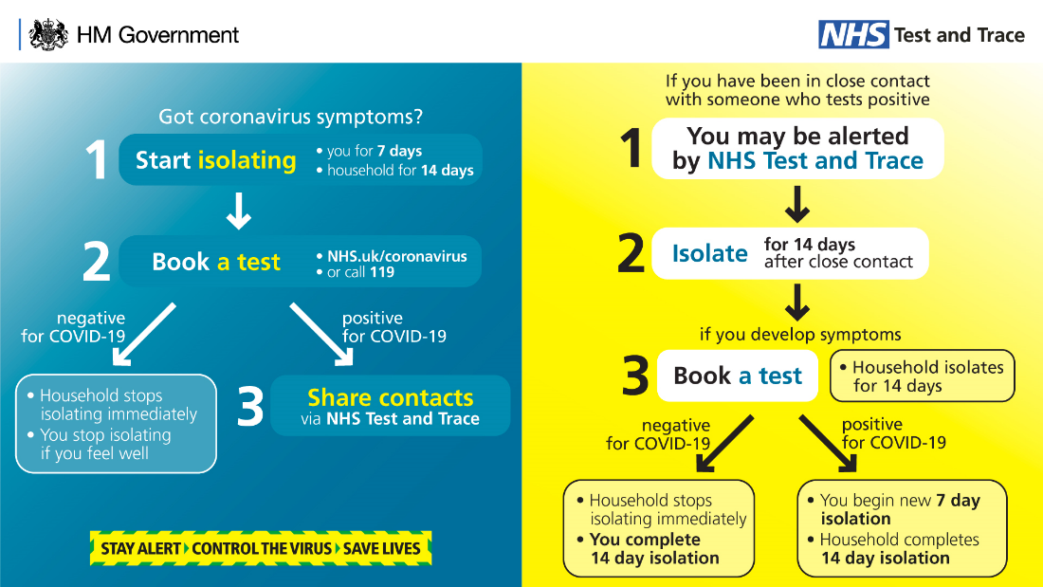
- Hygiene:
Handwashing should be in place after the following activities:
  - On arrival at school
  - After breaks and sport activities
  - Early Years: after using wheeled bikes, trikes and other large, movable toys
  - Before and after cooking and eating
  - Before and after handling children’s exercise books
  - After sneezing or coughing
  - After using the toilet
  - Before leaving for home
- Other hygiene measures:
  - Children should be taught how to wash their hands properly and be reminded of this regularly
  - Adults should be role models to the children with hygiene measures
  - Adults are reminded not to touch their face and to instruct children to avoid touching their own faces (and others)
  - Children should be instructed not to touch other people
  - Hand sanitisers are located around school for use in addition to washing hands with soap and water
  - Catch it, Bin it/Flush it, Kill it – used tissues to be put in double bagged lidded bins or flushed down toilets
  - Bins will be emptied every day (this will be monitored and frequency increased if necessary)

Wellbeing Support for staff:
- Any staff who require further support for own wellbeing can speak to
  - SAS https://schooladvice.co.uk/resources/
  - NST guidance http://www.nottinghamschoolstrust.org.uk/wellbeing-resources/
  - PAM assist https://www.pam-assist.com/
  - KP/AP/LD
  - SLT
  - Line managers
  - Phase teams
  - Each other

Wellbeing Support for children:
- Learning mentors will be able to run sessions with children but will not take children from across bubbles. Timetables will be established and adhered to by the learning mentors.
- Learning mentors will send a message via Teams chat to request the next child/group of children
- Only 1 child in a group room at a time – maintaining distance from adult
- Any group work must remain in the bubble
- CASY counsellor will work 1 day a week at each campus with identified children

Operational guidelines:
- Other staff members will be required to remain at a distance from other staff/children as to ensure bubbles are not burst.
- Clear signage will be around school and should be adhered to by all staff/children/parents
- Teachers and TAs will be assigned to a phase bubble.
- Only essential visitors will be able to enter school - Safeguarding visitor protocol and a contractor visitor protocol are in place and should be adhered to by school staff and the visitor
- Any appointments with parents will be over the phone; in some safeguarding cases SLT will determine the arrangements for a face to face meeting
- There will be no volunteers coming into school
- Supply cover will only be used as a last resort
- Any out of school visits will remain cancelled until further notice
- All meetings can be held virtually over Teams or Zoom (for larger groups of staff)
- Briefing will be shared on Newsfeed as in Summer term – all staff should read this when published each Thursday
- Assemblies will be virtual or timetabled for bubbles to be together in the hall
- The office should not be entered by staff who are assigned to a bubble – please communicate with the office via phones around school or via Teams chat or email
  - Windows to remain open/ajar at all times
  - Any non-fire doors to be propped open to avoid touching of door handles.
  - Adequate PPE will be provided for staff involved in cleaning and personal care. Government guidance states that it is not necessary to wear face coverings and other PPE whilst in school at other times (subject to update over summer)
  - All classrooms will be cleaned at the end of the day in addition to cleaning which will happen throughout the day by those in the bubble to maintain hygiene
  - All soft furnishings, soft toys and items which will be difficult to be cleaned to be removed from classrooms/group rooms
  - All unnecessary items will need removing from classrooms or putting away in cupboards/trays
  - Children must bring in their own water bottles and adults will use a jug to replenish the bottles unscrewed by the child
  - No drinking cups will be used in classrooms/shared areas
  - Office hatch windows will be kept closed at all times
  - Fire drills will be carried out periodically to ensure all staff and children are familiar with routes out of school and revised meeting points
  - Revised fire routes can be found on the plans on the back of doors
  - Behaviour policy has an appendix for the safety rules needed to be followed during reopening by children
  - Updated Safeguarding policy in line with KCSIE 2020 also has a Covid-19 annex which all staff must read
  - Individual risk assessments will be created/reviewed for any children or adults returning to school who may need additional measures in place

Guidance on daily routines:

Start of the Day
- There is a one-way system in place to minimise any congestion at gates and doorways
- Clear signs are around school, directing parents/children
- Waiting zones with distancing measures on playgrounds to avoid gatherings at doorways
- Each bubble/class will have a specific entry and exit to school
- 2 entry times and collection times grouped by surnames A-M and N-Z at 8:40- 8:50 and 8:50 – 9:00
- Children will go straight into class enabling parents to leave school promptly
- Year 5/6 children to be dropped off in the morning at the school gate
- Any lates will use the main entrance and make their own way to their classroom. The office will ensure they are taking the most direct route. The office will mark them in on the register and take dinner order.
- There will be no other register except the one on SIMs (no blue folder)

- Only 1 parent/carer to bring children onto school premises
- Staff member from the bubble should be at the allocated entrance to greet the children from 8:40 – there should also be an adult directing the children to wash hands (KS2 - before entering the classroom)
- Any lunchboxes from home can be stored on the trolley in the classroom (socially distanced)

Scotland Road
- The large and small gates will be open on the yard to allow for different entry and exits.
- Pavement outside of the entry gate will be marked for social distancing
- F2 Parents to accompany their children to the main EYFS door maintain as best they can social distance on the path

Breaktimes:
- Breaktimes will be staggered to ensure only 1 bubble or paired bubbles of children are on each playground at one time
- Each bubble will be allocated a playground to use
- Fixed play equipment may be used by a single phase bubble but must be cleaned daily
- Other play equipment will need cleaning between use
- Phases should use their own equipment for outdoor play which will need cleaning after break
- Children should be encouraged to play non-touch activities and no contact games

Moving around school:
- Children and adults moving around school should walk on the left-hand side to enable the corridors/stairs to be 2-way
- Movement around school will be limited to individual areas for each bubble of children and adults
- Please avoid using areas which are not assigned to your bubble
- KD Staffroom should be accessed via the Y3/4 stairs by all staff working downstairs
- Movement at lunchtime will be co-ordinated to ensure year groups do not mix
- MDSAs will only move between bubbles to support outdoor supervision or cleaning of the hall

Toilets:
- SR: Classes will have a timetabled rota for use of the toilets to avoid contact with others. Sinks in the classroom will be used for handwashing
- KD: only 1 child per class may visit the toilet at a time. Toilets should be allocated to specific named children.
- Sinks in the shared area will be designated to a group for handwashing

In class:
- We are operating in Phase bubbles.
- In addition KD classes are in paired bubbles in KS1 and Y3/4 for toilet access
- All classes should try to remain as a single bubble within a bubble for the majority of the time to reduce the number of interactions beyond the classroom
- Children will remain in their bubble at all times and with their designated adult. (teacher/TA/MDSA)
- Classrooms will be reorganised to enable as much space as possible between desks and with a 2m zone for the teacher at the front
- Desks should be arranged so that children will face forward (KS2)
- Classrooms will be accessed directly from an outside door where possible
- Teaching approaches should be used to enable social distance to be maintained as much as possible and minimal use of shared equipment
- Each class will have 5 daily ‘quarantine’ trays for items that have been touched and can’t be cleaned easily but are still needed for classroom work. These items will need leaving untouched for minimum of 48 hours (72 hours for plastics)
- Each class will have a ‘cleaning’ box for items to be placed in to indicate they need cleaning before the next person uses them if they can’t be cleaned immediately
- Staff are actively encouraged to use the outdoor space for learning outside the classroom – rotas are in place for teachers to sign up for slots each week.
- Teachers will teach their own PE sessions (2 over the week) PE subject leaders should support teachers with planning meeting RA conditions (no-touch/non-contact)

Lunchtimes:
- Children should sit maximum 3 per bench
- Lunchtimes will be staggered for tables to be cleaned between sittings
- MDSAs are assigned to each phase
- Children will be served at their tables instead of using the servery by their MDSA/TA
- Children will eat in the hall and spend the rest of lunch break outside
- KD: all children will enter the hall via the internal doors and leave via the external door to access the playgrounds (except EYFS)

Hometime:
  - p/t F1 children will finish at 11:40 (Mon-Thurs) and 11:50 on Friday
  - f/t F1 will finish at 11:50 on a Friday
  - 3:10pm children with A-M surnames should be at their allocated door ready for collection
  - 3:20pm children with N-Z surnames should be at their allocated door for collection
  - All parents will go to their drop off points and wait for their child to be dismissed to them and leave the yard via the small gate
  - release pupils as parents/carers arrive
  - Y5/6 children who can walk home alone will be dismissed at 3:30pm
  - ASC children will go to the hall at 3:30pm

Staffroom:
- Only 1 member of staff to use the kitchen area at any one time
- Cleaning products will be available to clean the area when you have finished
- Staff to maintain social distancing when in the staffroom
- Teaching staff and TAs will be given priority at set times during lunchtime to access the staffroom – due to space this may mean you are not able to spend the whole lunch break in there. KD Chameleons room and the Edible Playground (12:00 -12:45) may be used as additional lunch space
- Any staff who are able to access the staffroom at other times due to not supervising children should keep the staffroom free between 11:45 and 12:50
- Break times and lunch times will be staggered to enable all staff to access the staffroom at given times

Rainbow Club:
- Will run on Friday afternoons for specific groups:
  - children of working families who have no alternative childcare
  - Vulnerable children with social worker
- Will be run by teaching assistants and any teachers who are able to have PPA at another time or are part-time and are paid additional hours for PPA

First Aid:
- We are fortunate to have a high number of staff trained for first aid therefore all bubbles will have a first aider linked to the bubble
- Normal protocol will remain in place for dealing with first aid.

