HEathfield News

3RD JULY 2020 Kersall Drive Campus

The last day of term will be on Thursday 23rd July. School will remain closed throughout the Summer holidays to all pupils. School reports will be sent out by 13th July with a welcome letter from your child’s new class teacher. We are continuing to make plans for transition for the children moving year groups and will share this with you soon.
The Government released guidance yesterday for what needs to be in place for September. We will be contacting you in due course with our plans and what it means for all children coming back into school.

Rainbow Club:
This week the children have been ‘To Infinity and Beyond!’ with a Space theme to their learning. They have learnt about planets, astronauts, aliens, gravity and have finished the week making working rockets!
The children have been brilliant at keeping to their Rainbow groups and ensuring new children to the group have been shown the ‘new normal’ in school.

F2:
We would like to say thank you to the parents who have allowed their child to return to school this week. Our Foundation children have been fantastic settling into their bubble and for the Turtles, their new home in the Jellyfish classroom. All of the adults have been delighted to see how well the children have accepted the differences and are just getting on with their day. Our one-way route around school has worked well and we appreciate you following these rules too. The adults being role models to the children in sticking to our new rules helps enormously.

Year 1:
The children have again been making the most of the smaller classes and more attention from the adults in class. Both Miss Hampson and Mrs Fisher have commented this week on the progress children have made in different aspects of their work whilst not being in school which is good to hear.
Miss Dickens also tried some virtual Star of the Day assemblies which has worked well so this may be a new way forward so we can still have a daily assembly of some sort.

Year 6 leaving school:
Today we say goodbye to our first ever Year 6 cohort. Kersall Drive opened to pupils in 2015 when these children were just starting Year 2. They have been our oldest pupils all the way through and although the members of the year group have changed over time, the year group have shown maturity and been role models to the rest of the school.

We have imagined their final day with us for many years but we never imagined this situation. Even though we only have 9 of our Year 6 in school today we wish each and every one of them all the luck in the world as they move onto their next adventure at Secondary school. The children have had a lovely final day having a sports day, chilling out in class and eating Domino Pizzas!

We can’t wait to hear how they are getting on and hope to invite them back again to talk to the new Year 6 classes about their experiences of big school

Year 5 Returning to School on Monday:
Year 6 leaving allows us to invite our Year 5 pupils back before we break up for summer. Over half of the children are due to return and the teachers are looking forward to seeing them back in school.

Safety Protocols in School:
There is a thorough Risk Assessment for every aspect of school which is reviewed each week in light of additional Government guidance and feedback from staff in school. The children have noticed a difference in some aspects of school but have adapted very well. We have clear protocols for staff and children to follow which are sent to parents with the letter notifying you of year groups returning to school. We also have some short films giving the directions for parents dropping off and collecting the children.
If you are still unsure, please watch the videos which you will find on the website to get an idea of how school looks now.

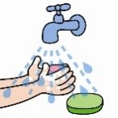
Stop the germs: Please could parents remind their children of the importance of good hygiene routines. There are some great handwashing videos on YouTube that use song and rhyme to encourage children to stay germ free.
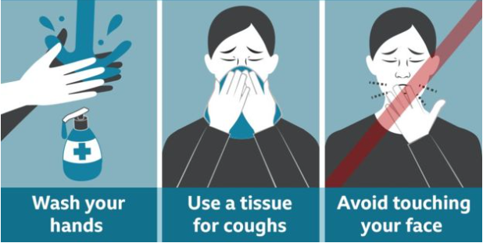
Encourage your child to wash their hands with soap and warm water for 20 seconds:
  - before leaving home
  - after using the toilet
  - after breaks and sporting activities
  - before food preparation
  - before eating any food, including snacks
  - on arrival at home

REMINDER: All children in school must have a named water bottle with them. If they do not bring one the office will call and ask you to bring one in – for hygiene precautions there are no cups for the children to use and the drinking fountains are switched off.

If the sun is out and the weather is warm they will also need a sunhat and sun cream either applied before the start of the day or with them which the child must be able to apply to themselves.

Dates for your diary:

