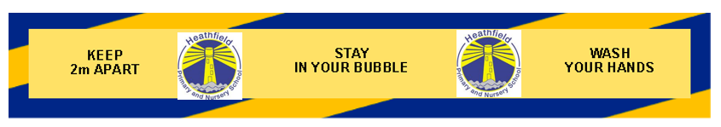
What measures will Heathfield implement to safeguard your child and your family?
Action | Safeguards in Place
Pupil Attendance | - If your child has a continuous cough and/or high temperature and/or loss of smell and taste they must not come to school and you have to call 111 to discuss potential testing  - Children WILL be required to wear clean school uniform each day and to wear their PE kit to school on the correct day instead of uniform  - Reporting Absence: Parents MUST inform school of any reason for their child’s absence to ensure that we are able to minimise any risk to the staff and other pupils.  - If any COVID symptoms are displayed overnight school must be informed ASAP so we are able to decide suitable course of action for the teaching staff and ‘bubble’ members who have been with your child
Pupil Arrival | - Please arrive during your allocated time.  - No more than 1 parent per family  - Children will go straight into their classroom from their allocated drop off point  - Children MUST NOT play on the outdoor equipment and should remain 2m away from other children/families  - NO CHILD should be in school if symptomatic, they will be isolated immediately and sent home  - Following guidance from Public Health England, children will not wear PPE in school
Handwashing  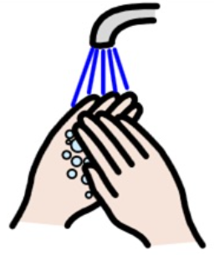 | - Children will be taught how to wash their hands properly and reminded of this regularly.  - Children should wash their hands after the following activities:  - on arrival at school  - breaktime, lunchtime and sport activities  - using shared resources  - before and after cooking and eating  - sneezing or coughing  - using the toilet  - Children will be regularly reminded not to touch their face  - Hand sanitisers will be located around school for use in addition to washing hands with soap and water
School Staff | - Your child will be taught in a class bubble which is part of a larger phase bubble  - Staff will communicate with parents via text, email and phone calls when needed as no parents are allowed in the classrooms  - Office staff will allow 1 parent at a time into the school reception area
Classroom | - Children MUST bring a named water bottle into school each day – the water fountains are not in use  - Children will have their own set of resources for learning  - Children will be expected to follow the school rules and new safety rules
Behaviour  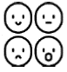 | - Behaviour Expectations will be clearly displayed and included in the policy on the website  - Social distancing rules have been added to the behaviour policy and will be explained clearly to all children as they start in September  - If your child does not follow school rules and puts other children at risk, they will be at risk of exclusion
Toilets  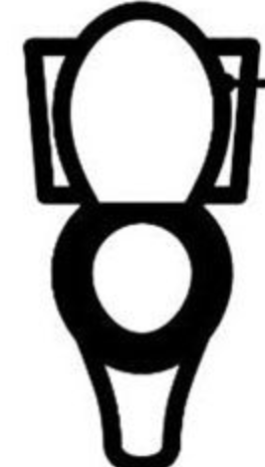 | - Toilet flush handles/buttons and taps will be cleaned regularly  - Children must wash hands thoroughly after using the toilet
Break | - Children will remain in their bubble and will not mix with children from other phase bubbles  - Bubbles of children will have access to playgrounds on a rota basis  - All games will be non-contact games  - No tuck shop for Key Stage 2 children until further notice due to money handling and concerns over bubble bursting
Lunch | - Children will be supervised by a designated midday supervisor  - Children will eat their dinner in the hall  - Children will sit within their bubble  - Midday supervisors will serve the children at the tables  - Children will have access to their allocated playground over lunchtime
First Aid/Child with Symptoms | - There are first aiders in each phase bubble  - If children develop symptoms such as continuous cough and/or high temperature and/or loss of smell and taste at school they will be moved to an isolation room and parents will be asked to collect them immediately  - Please ensure the office have your up to date contact details in case of emergency – check SIMs ParentLite app  - The member of staff supervising any symptomatic child will wear full PPE
Cleaning through the day  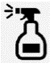 | - Staff in each bubble will have cleaning products to use for resources, surfaces and touch points to use as required  - Children will place items such as reading books into the quarantine boxes in class to help ensure resources are free of virus before their next use.
Home Time  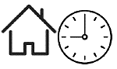 | - Please be on time to collect your child (see newsletter 23.7.20)  - No more than 1 parent per child/family  - Year 5/6 children who are walking home alone will be dismissed at the end of the normal school day  - Parents must wait at their allocated collection point for a member of staff to dismiss your child. Please follow 2m social distancing whilst on the premises  - Dedicated in and out gates to be used in line with the one-way system in place  - Children and families must leave the school premises immediately  - Gates will be locked at 3:30pm

