P.E. Activity
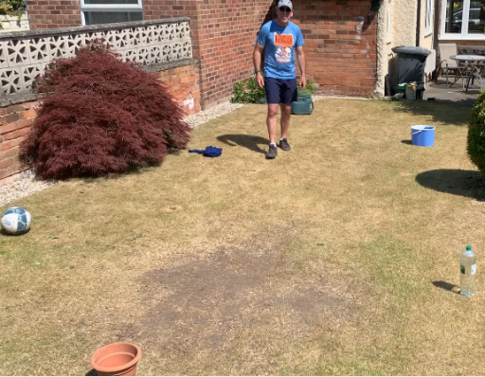
Find yourself space in your garden and set out 6 objects to make a circuit. One of the items must be a full plastic bottle and another should be a skipping rope, jumper, scarf or leggings.
Warm yourself up by doing 10x jumping jacks and running with shuffle steps from the centre of your circuit to each stations and back to the centre.
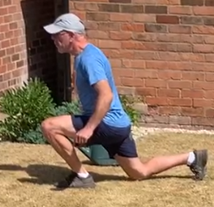
Exercise 1
Keeping your back straight, lunge forward on one leg, make sure your back knee touches the floor. Then return to standing position and repeat with the other leg. Do this 5x each leg.

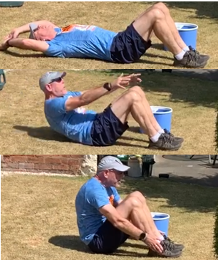
Exercise 2
Lie on the ground with knees up and feet and flat on the floor and your arms up behind your head
Bring your arms up and over and lift your body off the floor.

Reach forward and touch your toes before raising your heads and lowering yourself back to the starting position
Repeat this 10 times.

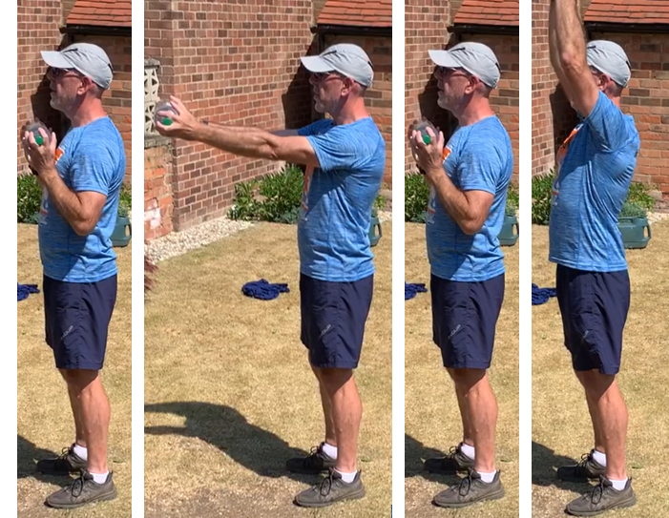
Exercise 3
Hold the bottle at chest height, push your arms forwards, bring them back to your chest then raise the bottle above your head. Repeat 10 times.
Keep your back straight and your body still – it is important not to wobble about when you carry something above your head.

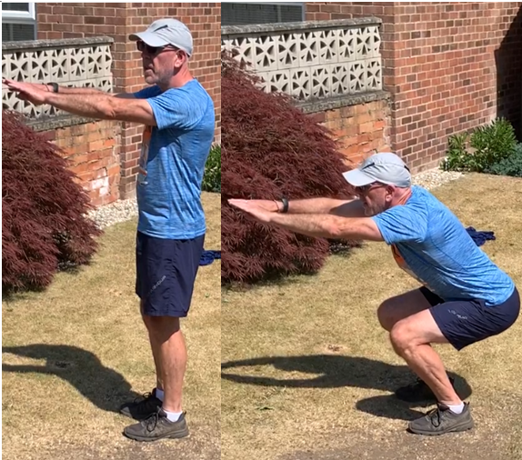
Exercise 4
Stand with your back straight and your arms out in front of you. Bend your legs (not your back) and lower yourself as if about to sit down into a chair. Keeping your back straight and face looking forward raise yourself back to a standing position and repeat 10 times

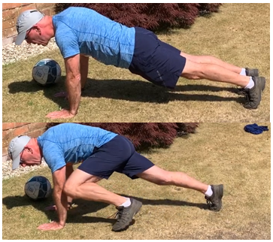
Exercise 5
Stretch on the floor with your hands under your shoulders.

Bring your knee up to the elbow and then back, swap to the other leg and repeat 5 times for each leg.

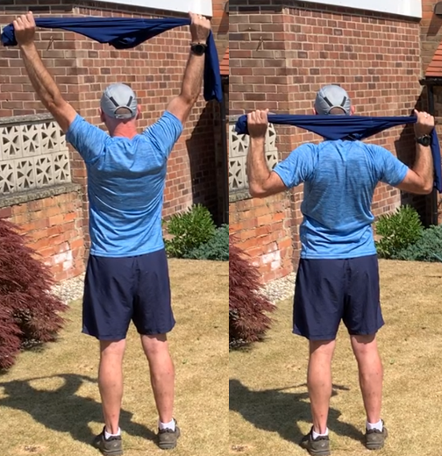
Exercise 6
Hold your skipping rope, leggings, jumper or scarf above your head. Keep it stretched out and slightly behind your head to stretch your shoulders. Your arms will make a V-shape.
Next lower your arms keeping the skipping rope stretched out tight and still behind your head. Your arms now make a W-shape. Repeat 10 times.

When you have finished have 2 or 3 mouthfuls of water and try again but only do 8 repeats.
Work your way down the 2x table until you are only doing 2 repeats.

Try again another day but work up the 2x table starting at 2 and finishing with 10 repeats.

