Global Day June 26th 2020
At Heathfield Primary and Nursery School we enjoy learning about the world we live in and learning from the different cultures of the world. This is something that we do all the time. However, Global day is an extra special time for us to celebrate and explore the art, history, geography, values and beliefs of people from different cultural backgrounds. Over the past few years we have also been learning about UNESCO.

UNESCO works all over the world to help protect special and important places, called World Heritage Sites. UNESCO World Heritage Sites might be a building, a river, part of the ocean, a forest, ruins of an ancient building or even a waterfall.

We would still like to celebrate Global Day this year and here are some of the things that we can all get involved with.
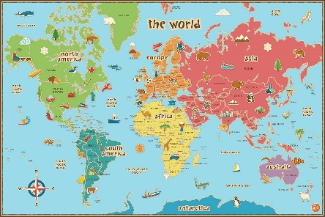
First of all, choose a UNESCO World Heritage site that you would like to learn about. One is enough but you can do as many as you like. This website will help you. whc.unesco.org/en/list/
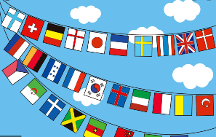
Make some bunting and decorate it using world flags. You could also learn some words in different languages and write them on the bunting.

Make a 3D model or create a piece of art about your UNESCO World Heritage site.
Create a fact file of your chosen UNESCO World Heritage site and include some facts about the country where your chosen site is located.
Make a travel guide.
Do some international cookery.

Finally, please take lots of pictures and share them using the school twitter account.

