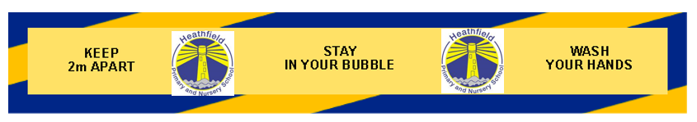
What measures will Heathfield implement to safeguard your child and your family?
Action | Safeguards in Place
Pupil Attendance | - Only children with a confirmed place can attend  - Children without a confirmed place will not be allowed in the school building – school need 1 week’s notice of additional places  - If your child has a continuous cough and/or high temperature and/or loss of smell and taste they must not come to school and you have to call 111 to discuss potential testing  - Children WILL be required to wear clean school uniform each day but will not require a PE kit  - Reporting Absence: Parents are required to inform school as to any reason for their child’s absence to ensure that we are able to minimise any risk to the staff and pupils. If any COVID symptoms are displayed overnight school must be informed ASAP so we are able to decide suitable course of action for the teaching staff and ‘bubble’ members who have been with your child.
Pupil Arrival | - You will be allocated a drop-off/pick up time TBC  - Please do not arrive before this time  - No more than 1 parent per child/family  - Dedicated in and out gates to enter school – follow the signs  - Children will go straight to their classroom from their allocated drop off point  - Children MUST NOT play on the outdoor equipment and should remain 2m away from other children/families  - NO CHILD should be in school if symptomatic, they will be isolated immediately and sent home  - Following guidance from Public Health England, children will not wear PPE in school
Handwashing  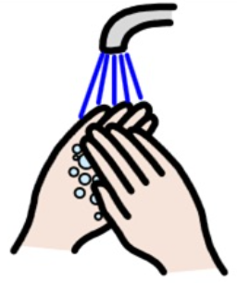 | - Children will be taught how to wash their hands properly and reminded of this regularly.  - Children should wash their hands after the following activities:  - on arrival at school  - breaktime, lunchtime and sport activities  - using shared resources  - before and after cooking and eating  - sneezing or coughing  - using the toilet  - Children will be regularly reminded not to touch their face  - Hand sanitisers will be located around school for use in addition to washing hands with soap and water
School Staff | - Your child will be taught in a small group – “bubble” of up to 10 children  - We will endeavour to keep the same staff with your child  - Staff will communicate with parents via text, email and phone calls when needed as no parents are allowed in the classrooms  - Office staff will allow 1 parent at a time at the school reception  - Staff will have access to PPE when required
Classroom | - Children will remain in their own part of the classroom, protecting their bubble from other groups  - Children will have their own set of resources for learning  - Children’s coats will be kept on an allocated peg  - Children must bring a named water bottle into school each day  - Children will be expected to follow the school safety rules  - Children are NOT allowed to bring any additional items from home
Behaviour | - Behaviour Expectations will be clearly displayed  - The new rules have been added to the behaviour policy and will be explained clearly to all children  - If your child does not follow school rules and puts other children at risk, you will be asked to collect them immediately
Toilets | - Only 1 child will be allowed to use the toilets at a time within an allocated time slot  - Kersall Drive shared toilet facilities will be partitioned to prevent children from different groups mixing whilst in there  - Toilet flush handles/buttons and taps will be cleaned regularly  - Children must wash hands thoroughly after using the toilet
Break | - Children will remain in their small group and not mix with the others  - Groups of children will take turns to access the playgrounds  - All games will be non-contact games
Lunch | - Children will wash their hands before and after lunch time  - Children will be looked after by a designated midday supervisor  - Children will eat their grab bag meals in the classroom  - Children will have access to their allocated playground over lunchtime
First Aid/Child with Symptoms | - There are a number of first aiders on site who will provide first aid as necessary  - If children develop symptoms such as continuous cough and/or high temperature and/or loss of smell and taste at school they will be moved to an isolation room and you will be asked to collect them immediately  - Please ensure the office have your up to date contact details in case of emergency  - The member of staff supervising that child will wear full PPE
Cleaning through the day  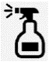 | - Cleaners will be on site each day to clean surfaces and touch points  - Toilets will be cleaned daily  - Each bubble will have the appropriate cleaning resources available  - Staff in each bubble will have cleaning products to use for resources, surfaces and touch points to use as required  - Wednesday’s closure will allow for a deep clean mid-week
Home Time  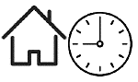 | - You will have an allocated collection time for your child to avoid large gatherings by classroom doors and gateways  - No more than 1 parent per child/family  - Parents must wait at their allocated collection point for a member of staff to dismiss your child. Please follow 2m social distancing whilst on the premises  - Dedicated in and out gates to be used in line with the one way system in place  - Children and families must leave the school premises immediately

