YEAR 3 HOME LEARNING BOOKLET

MATHS
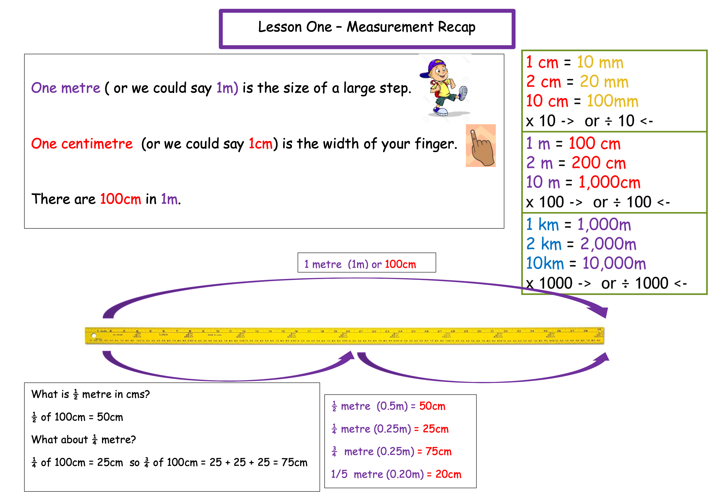

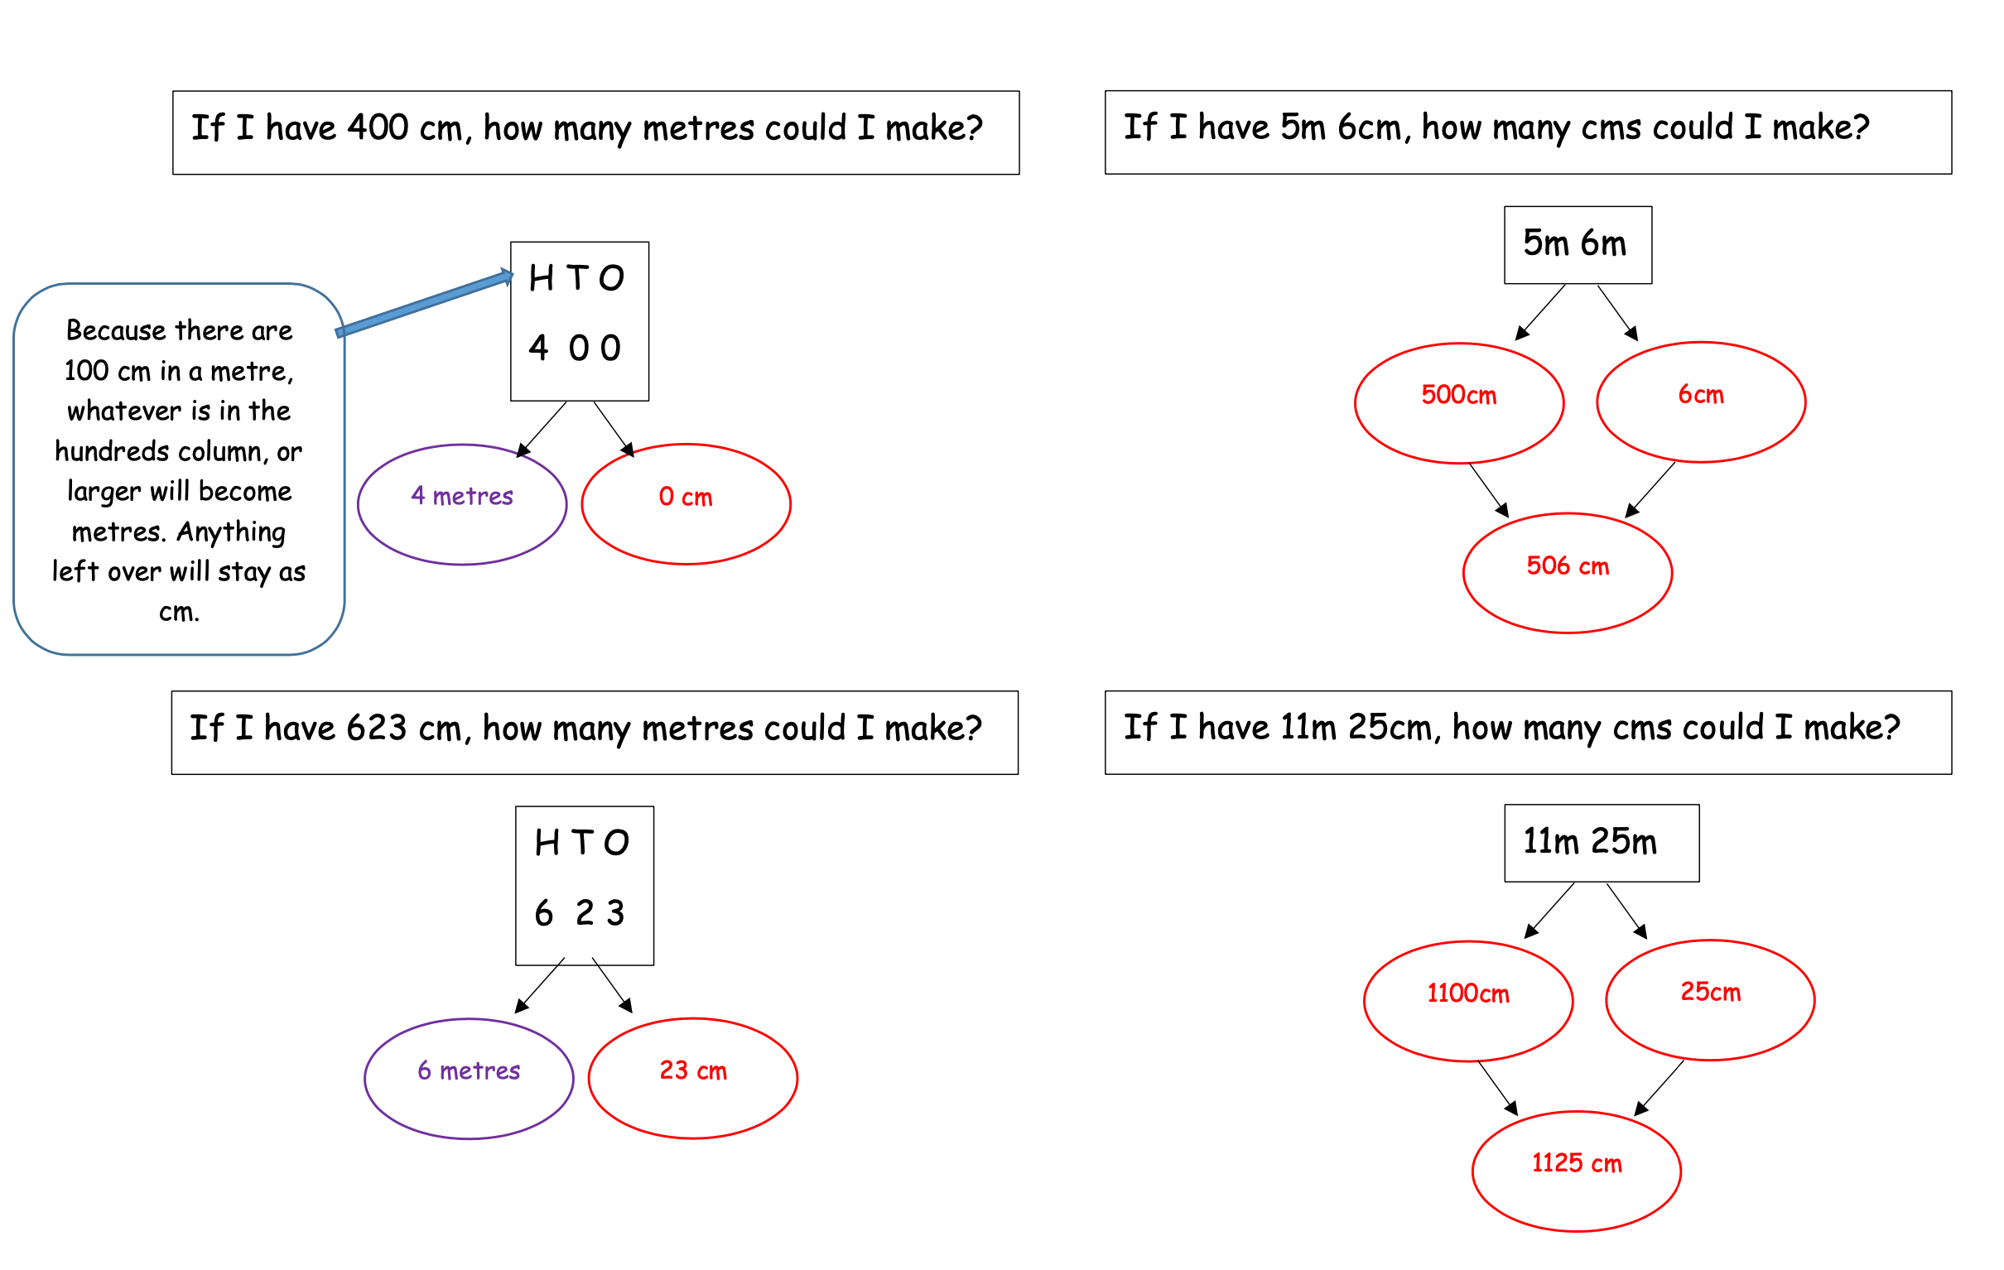

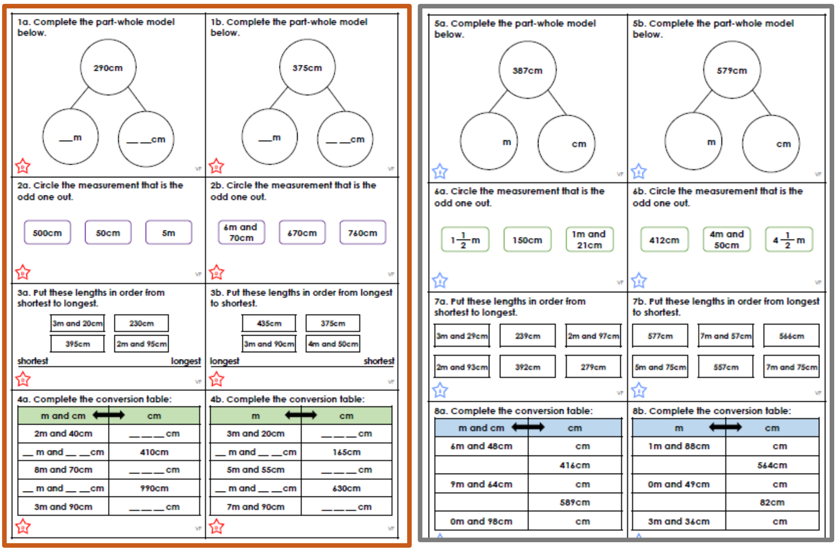

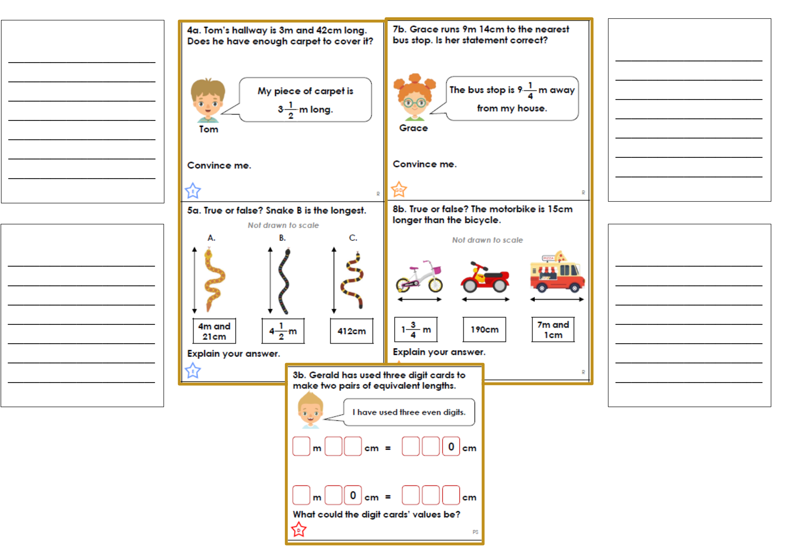
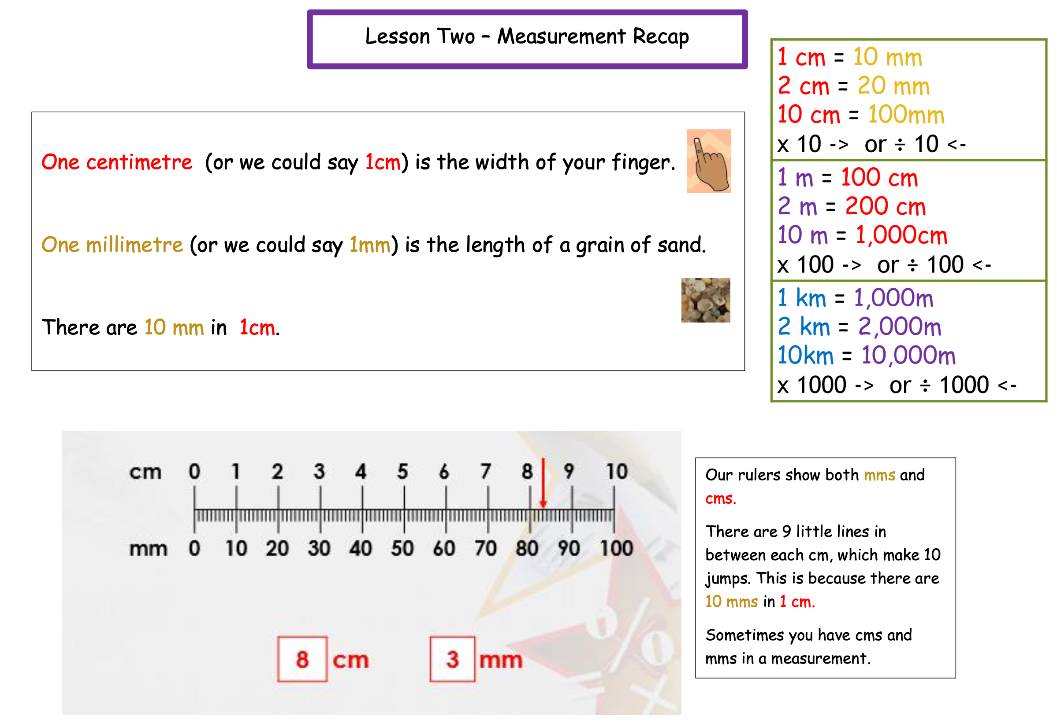

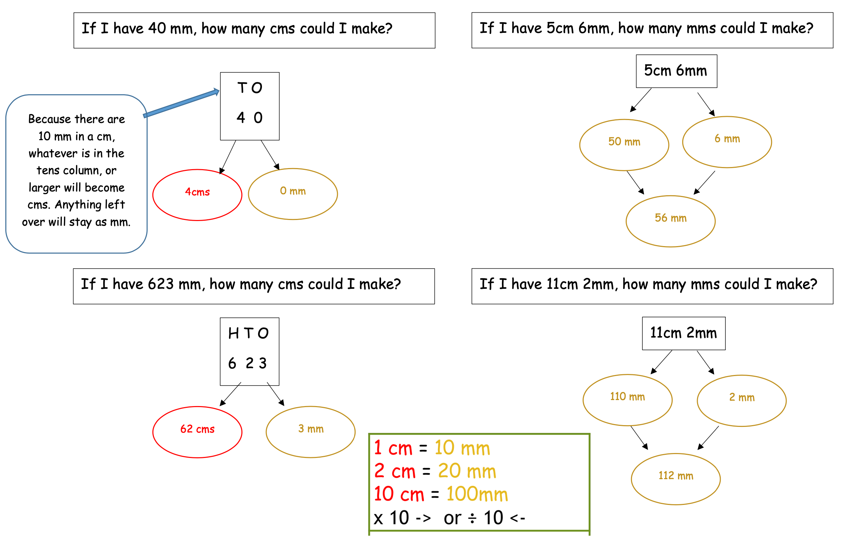
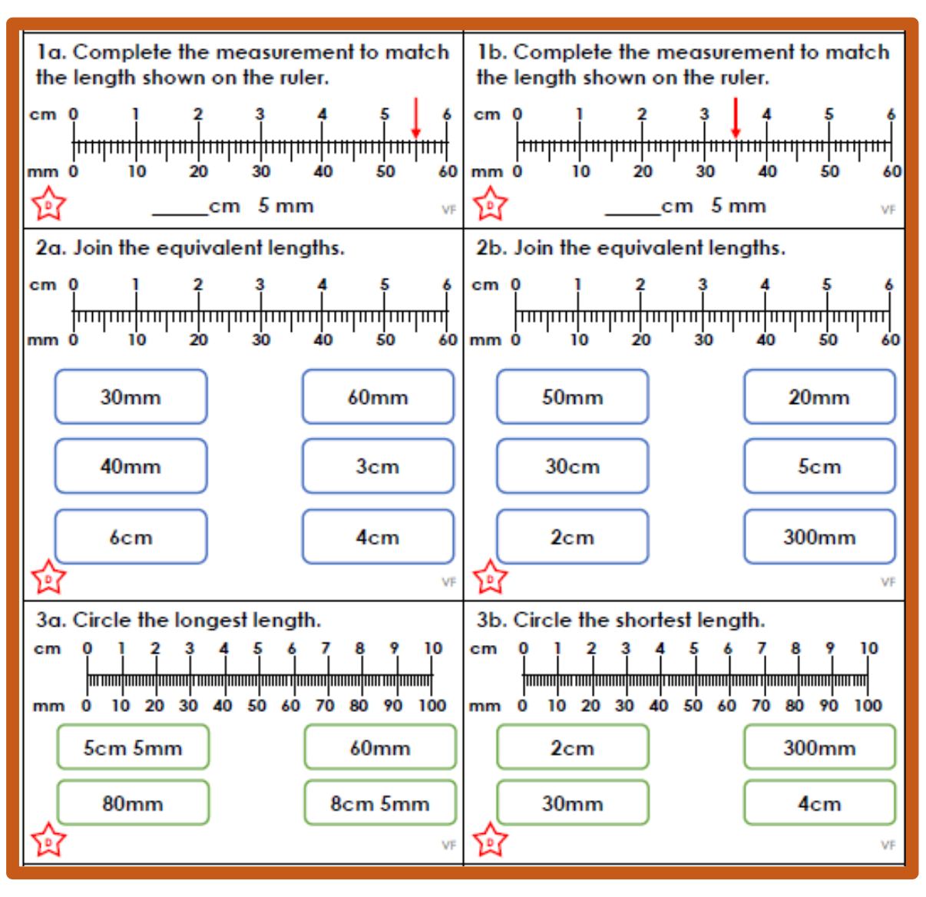

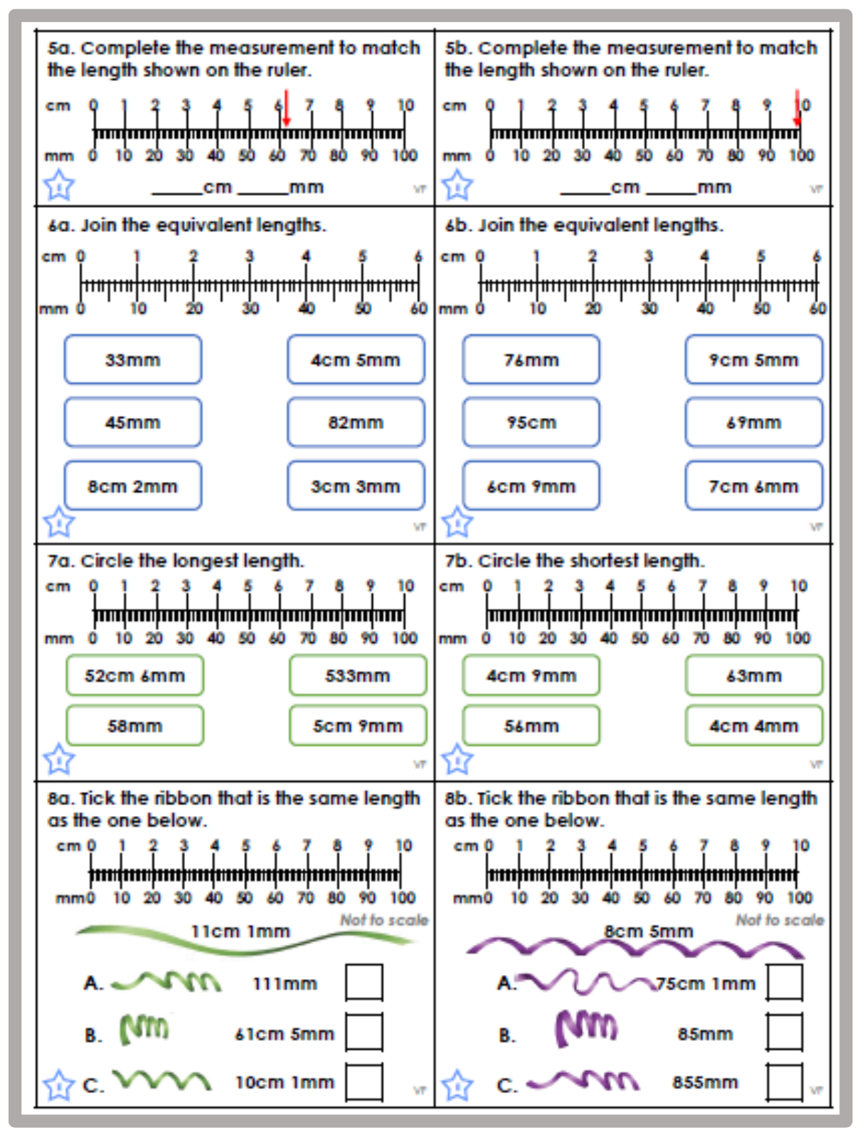

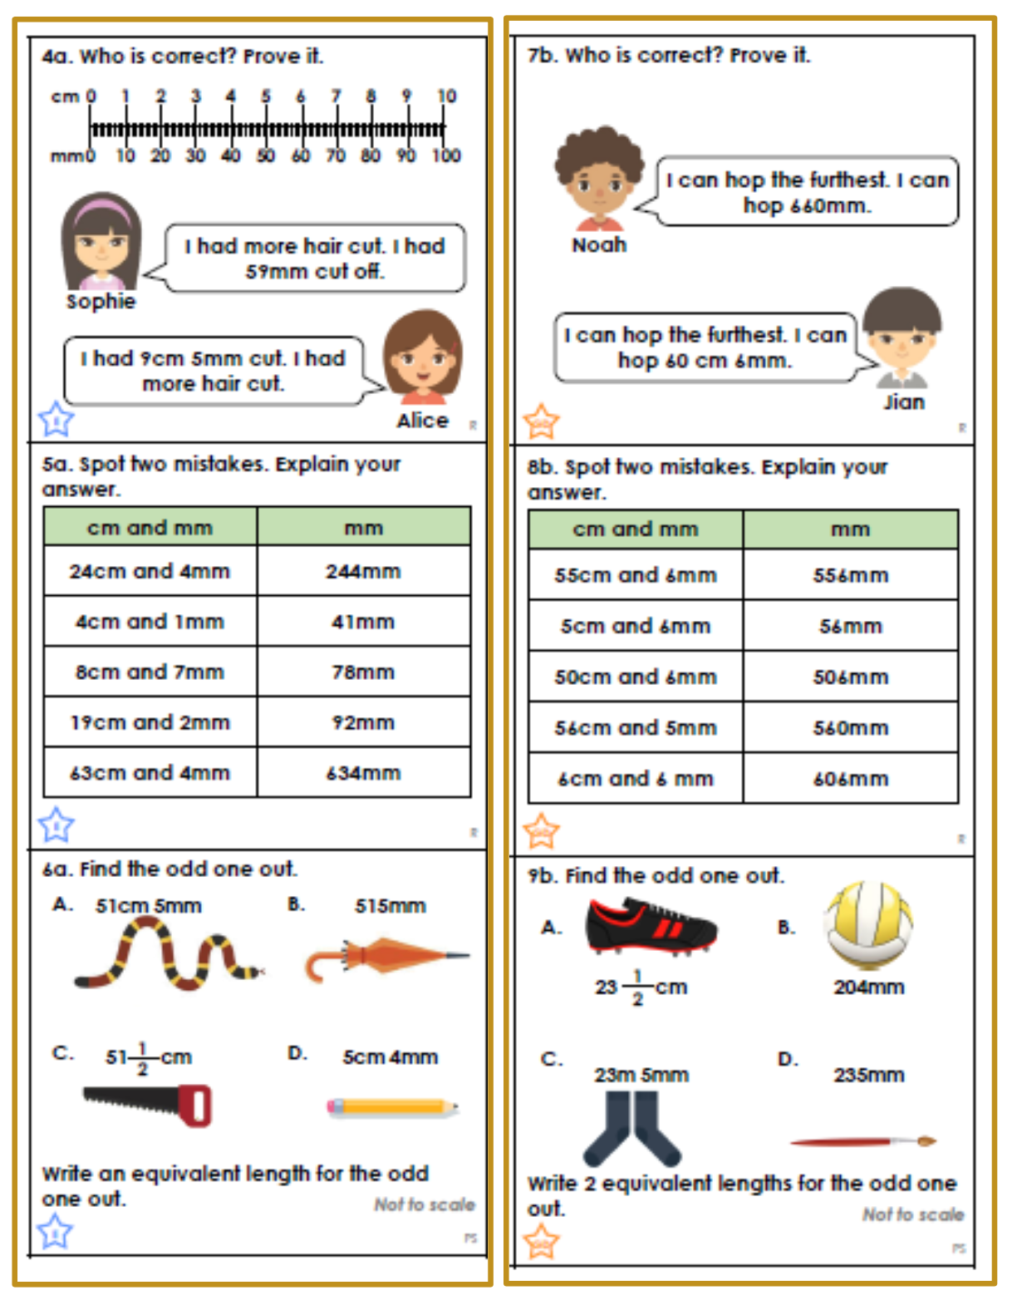
Platinum:
4cm 5mm
I could write this as - 3cm 15 mm
- 2cm 25mm
- 1cm 35mm
- 45mm
How many different ways could you write the length:
14cm 7 mm
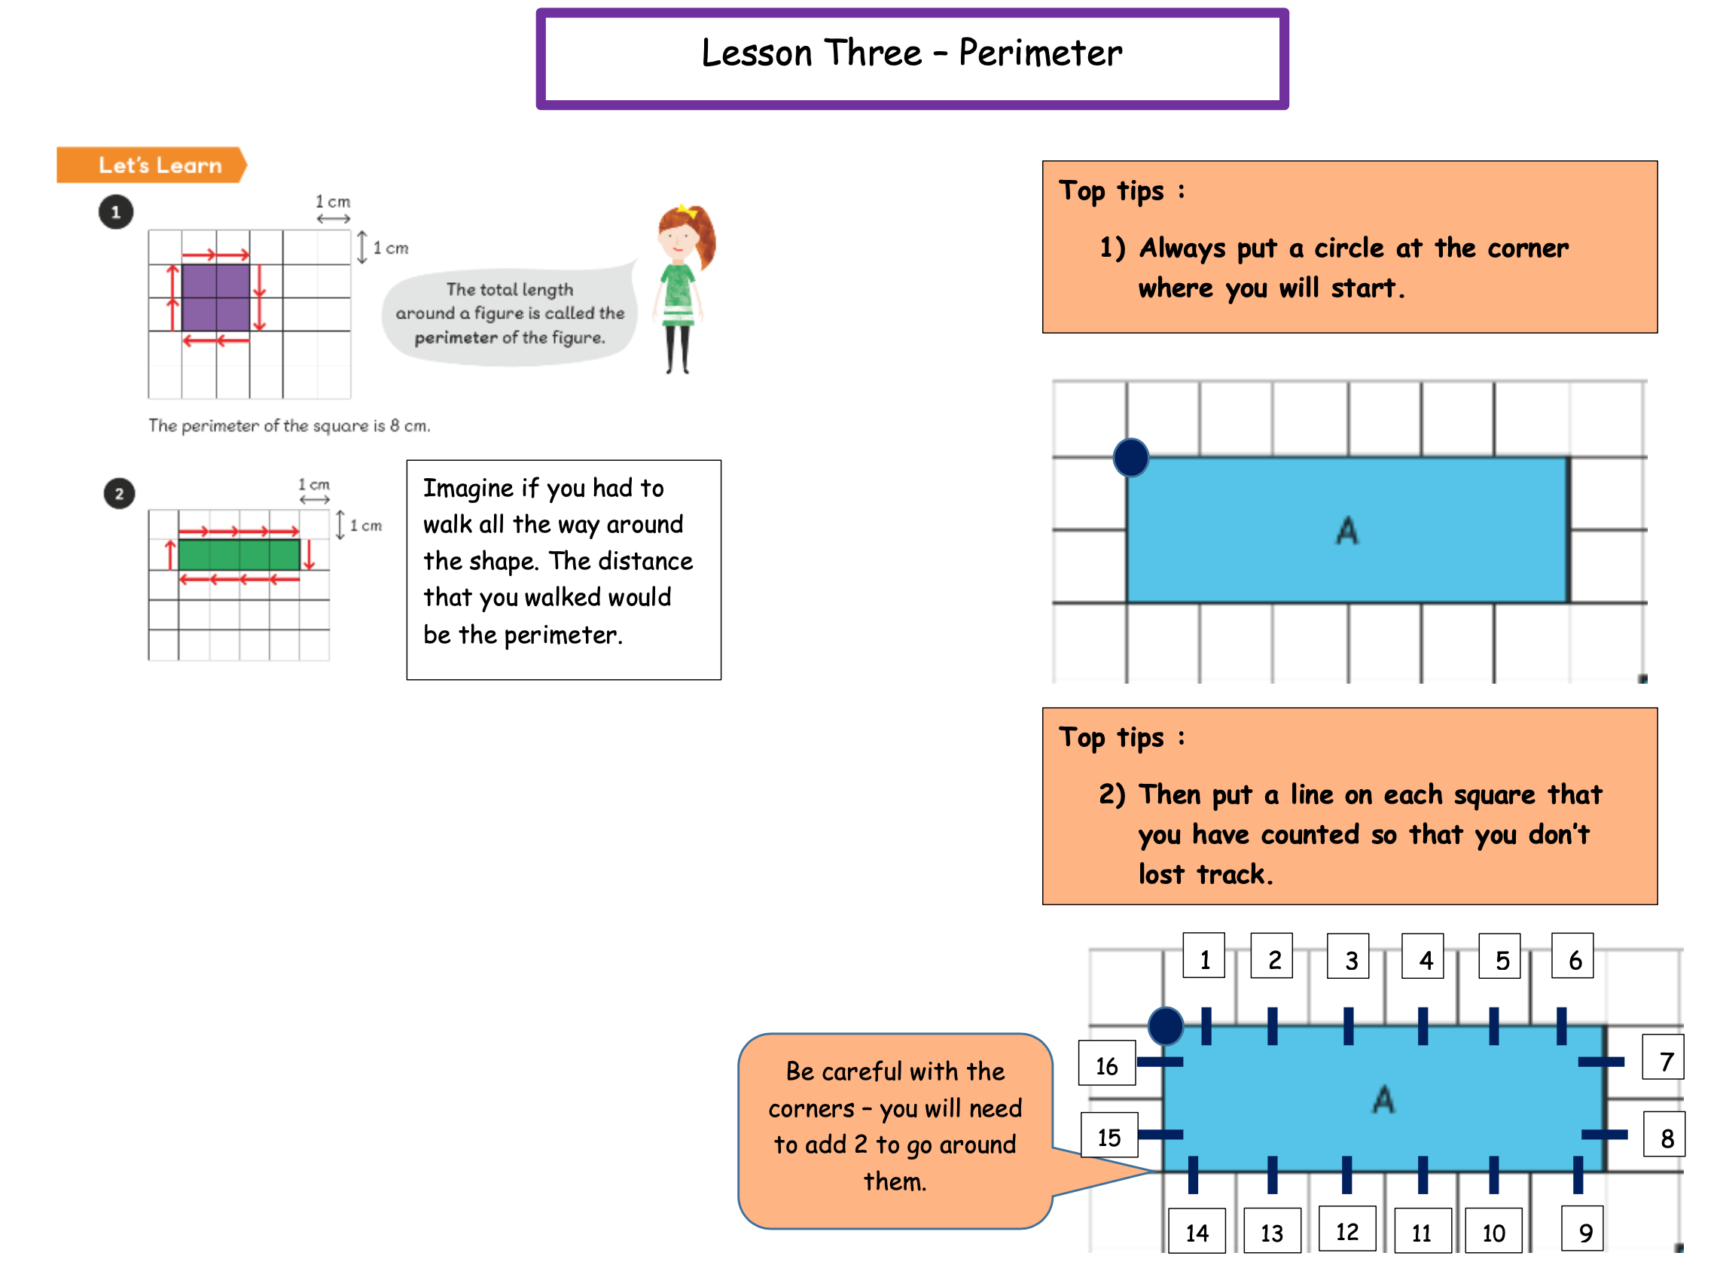

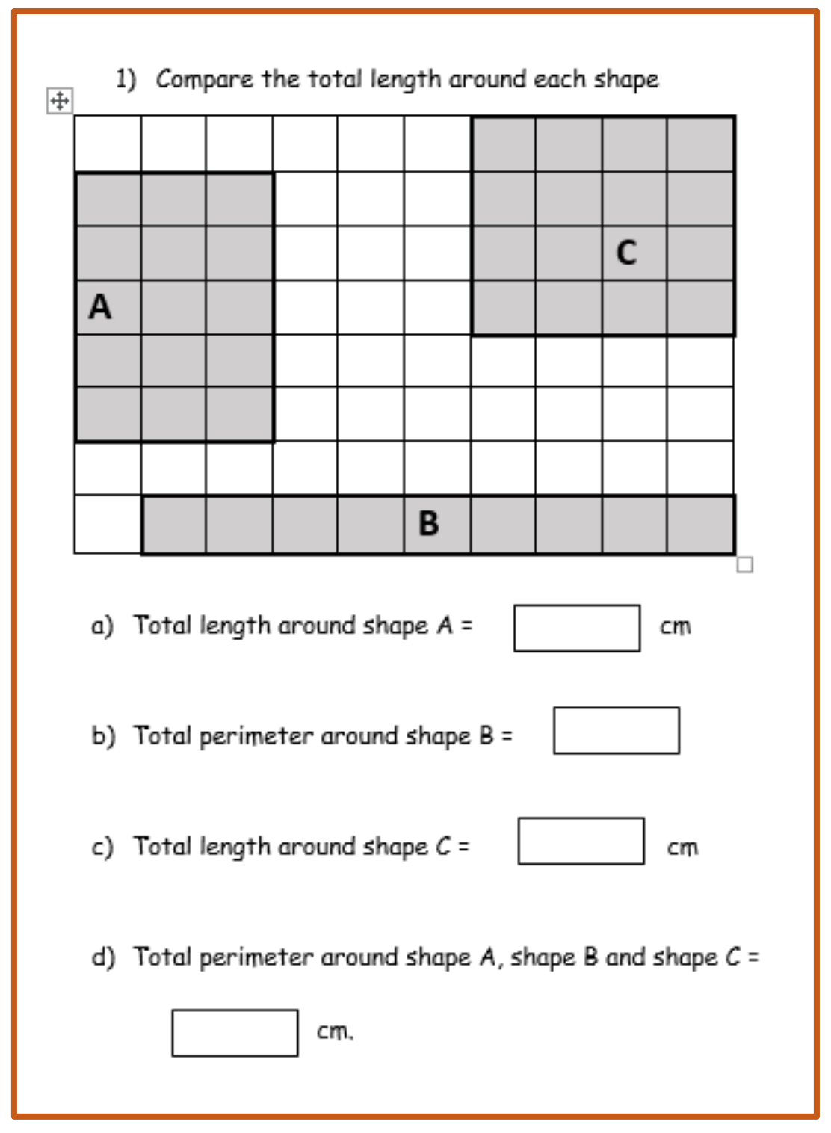

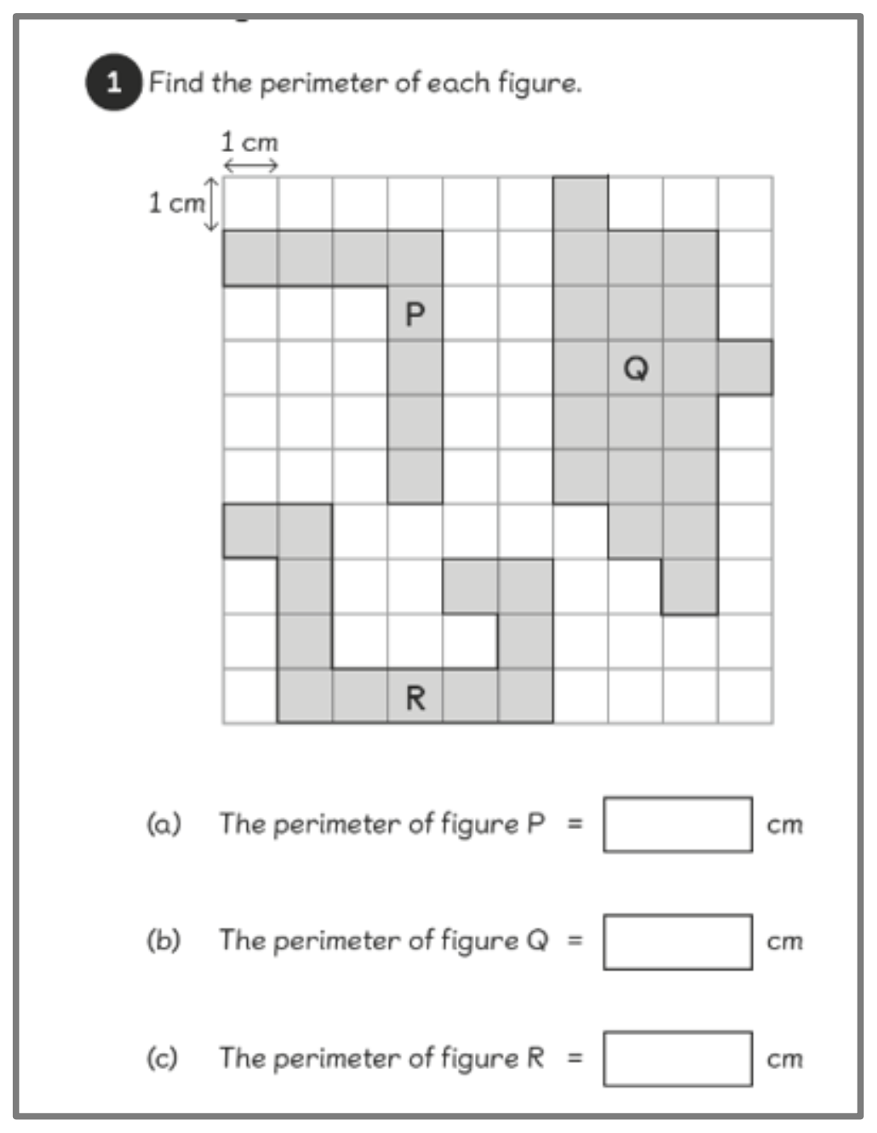

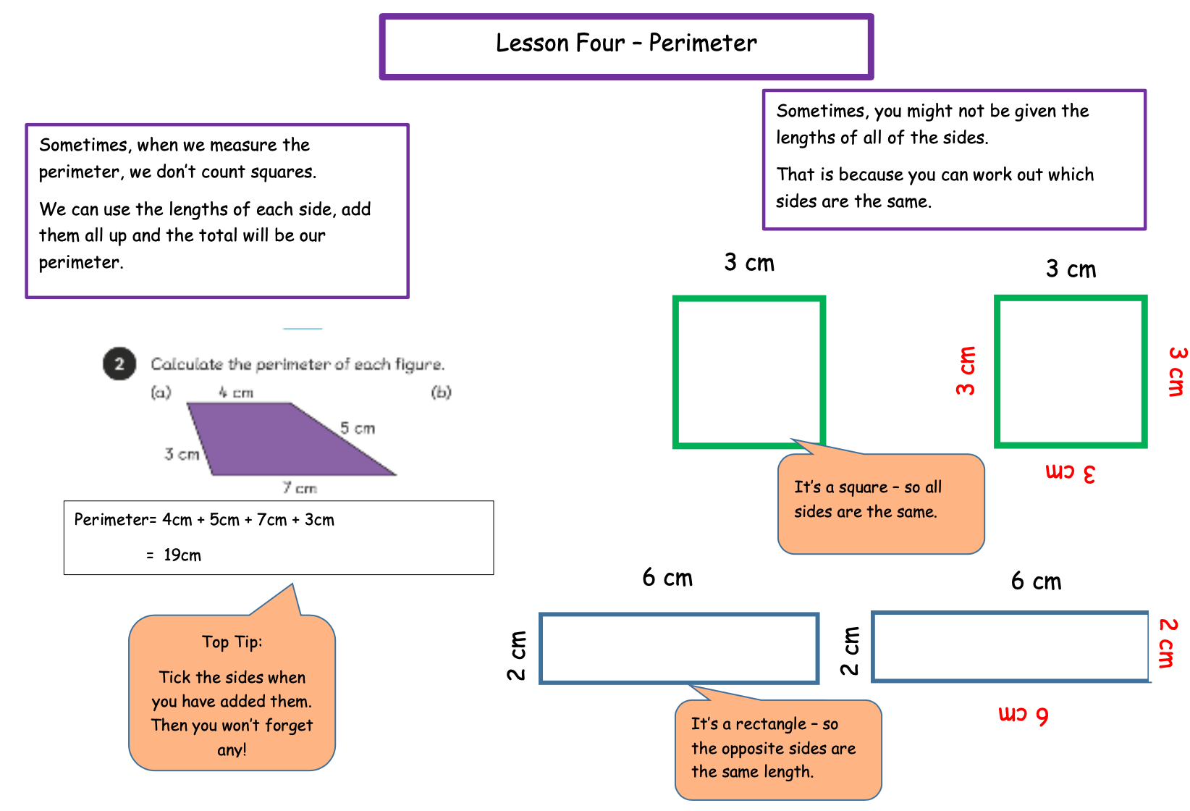

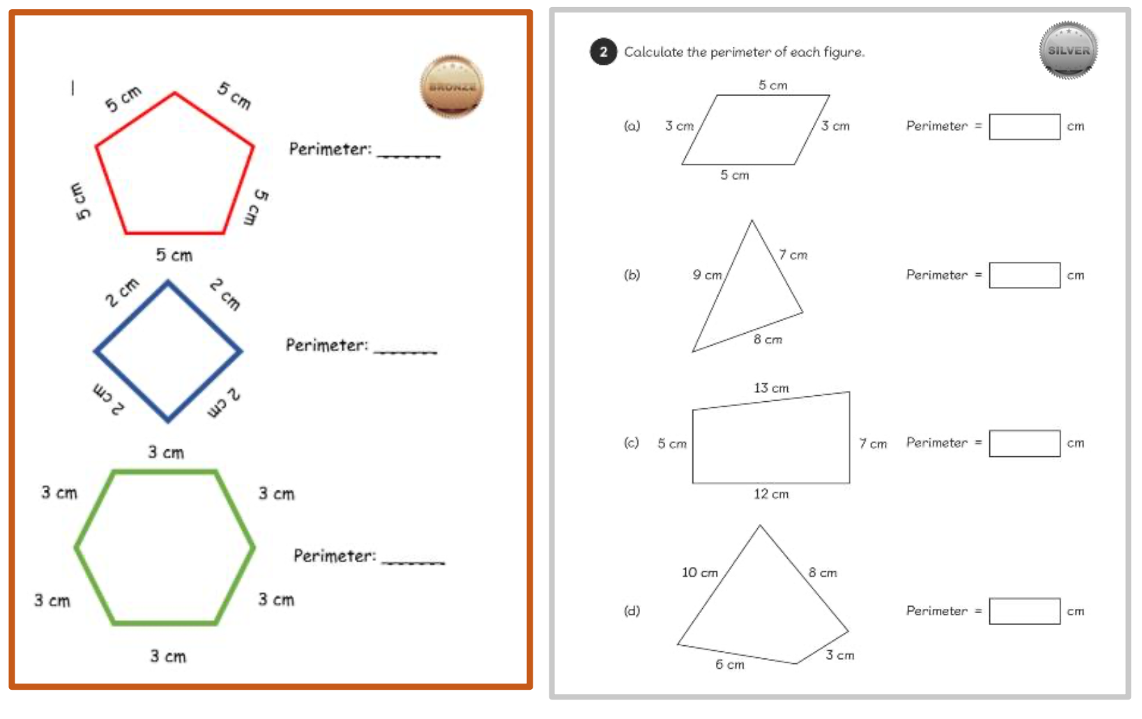
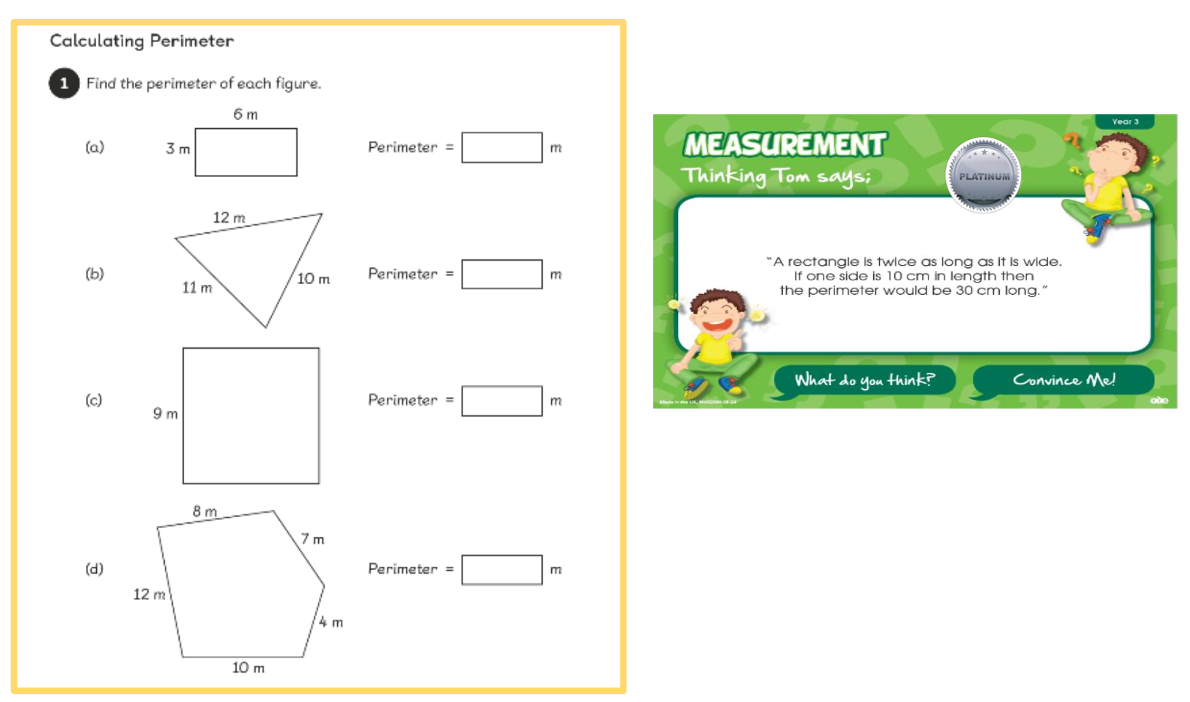

WRITING
Creative Writing
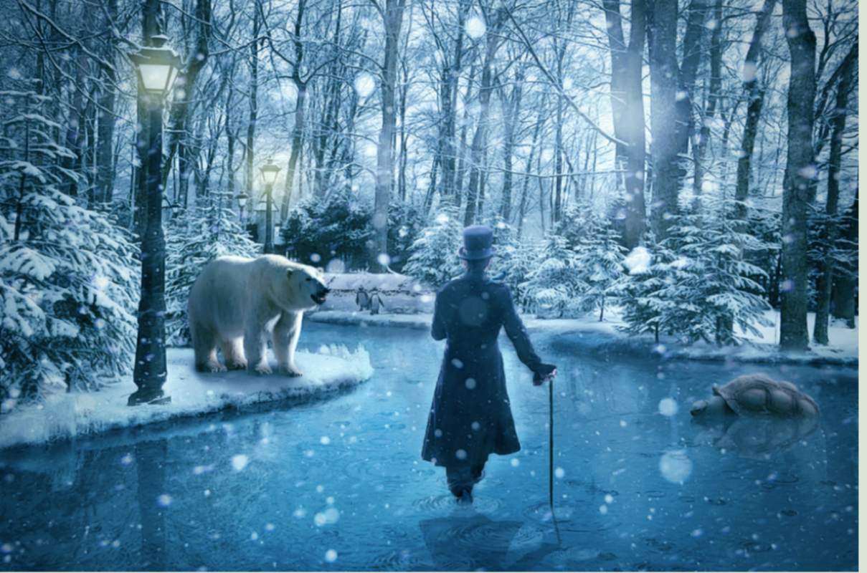

‘The Winter King strolled confidently through the river of ice. This was HIS domain. Here, it was always winter.’

Using the picture and sentence above, can you writing a descriptive paragraph of what The Winter King could see, hear, touch and smell while he is walking through his kingdom?
There are some helpful tips for improving your writing on the next page

Don’t forget to use expanded noun phrases!
Use two adjectives to describe your noun and a verb to explain what it is doing.
Bleached white, colossal polar bears marched side by side.

Use different sentence types.
For example:
Question sentences - How could such a large beast walk across such delicate ice?
What about subordinating conjunctions?
If, so, although, as, while, before

Write using your senses!
Don’t just write about what can be seen.
What about the smell of crisp winter air?
The sound of howling polar bears?
The icy cold snow making your sending shivers down your spine?

Make sure to use interesting language!
Use a dictionary or thesaurus if you want to up-level your language

Don’t forget to explain what different things are doing!
Don’t just describe the snow, explain what the snow is doing
For example:
Glistening white snow fluttered down from the cool blue sky.

Acrostic poems spell a word out vertically down a page. This is the theme of the poem.
Each line of the poem begins with the letter on that line and must link to the theme.
EG. FIREWORKS
When writing an acrostic poem you have to think of exciting and interesting vocabulary to use.
The example above describes the fire. Rather than simply telling the reader there is a fire, it describes what the fire is doing.
Flames flicker in the bonfire
You could improve this further by describing the bonfire as well…
Flames flicker in the dazzling bonfire

Now you try!
Can you write your own acrostic poem about one of our topics this year (Africa, Our Wonderful World, Tudors, or Virtual Reality) on the next page?
You do not have to use Africa, Our Wonderful World, Tudors or Virtual Reality as your title/theme. You can pick something to do with that topic to use as the theme of your poem.
For example:
Tudors - HENRY VIII, PUNISHMENT, SIX WIVES, or TUDOR ROSE
Africa - ELEPHANTS, RHINOS, SAVANNAH, or CONSERVATION
Our Wonderful World – EARTH, EXPLORE, DIVERSITY, or CURIOUS CREATURES
Virtual Reality – COMPUTERS, TECHNOLOGY, NEW WORLD, or DISCOVER
These are just examples you could use, if you have your own ideas then go for it! Get creative!
BANISH BORING WORDS!
Don’t forget to use interesting vocabulary!
Adjectives! Verbs! Adverbs!
If you’re stuck for ideas use a thesaurus/dictionary.

FACT FILES

Write a fact file about an animal of your choosing, this can be linked to our Africa topic or about your pet at home.
Remember when writing a fact file you must include:
a title
subheadings
factual information
statement sentences
question sentences
fronted adverbials
pictures to make it more eye catching!
Make sure to explain what your animal is, where your animal lives (country and land type) and if they live in a group, what they eat, and what special/interesting skills they have.

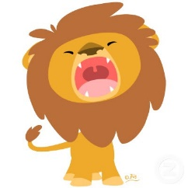
An example of a good fact file is on the next page…
African lion
African Lions facts.

Lions are one of the most feared predators in the world. They are the biggest of all wild cats. If you want to find out more about this magnificent beast, read this fact file…
Lions Habitat
African lions are mostly found in sub-Saharan Africa. They used to be found all over Africa but now they have mostly disappeared from North Africa and are at risk of extinction in West Africa. Lions live in savannahs and grasslands. Lions are the only cats that live in groups. A group, or pride, can be up to 30 lions, depending on how much food and water is available.

Lions Diet
Did you know that lions are carnivores? This means they only eat meat. Lions hunt for food every few days. They will feed from their kill and then rest until they hunt again. They usually kill medium sized mammals, such as zebra, deer and wildebeest.

Special Skills
Did you know that a lion’s roar can be heard from up to 8km away? Surprisingly, lions scent mark their territory, using their wee, to create a border. Did you know lions are the laziest of all the big cats, and can sleep for 16-20 hours each day.
Conservation
Unfortunately, the number of African lions in the wild is declining and they’re now thought to be at risk of extinction. Over the last ten years their numbers have gone down by 30%. The main threat facing African lions in the wild is being killed as part of organised hunts.

Reading

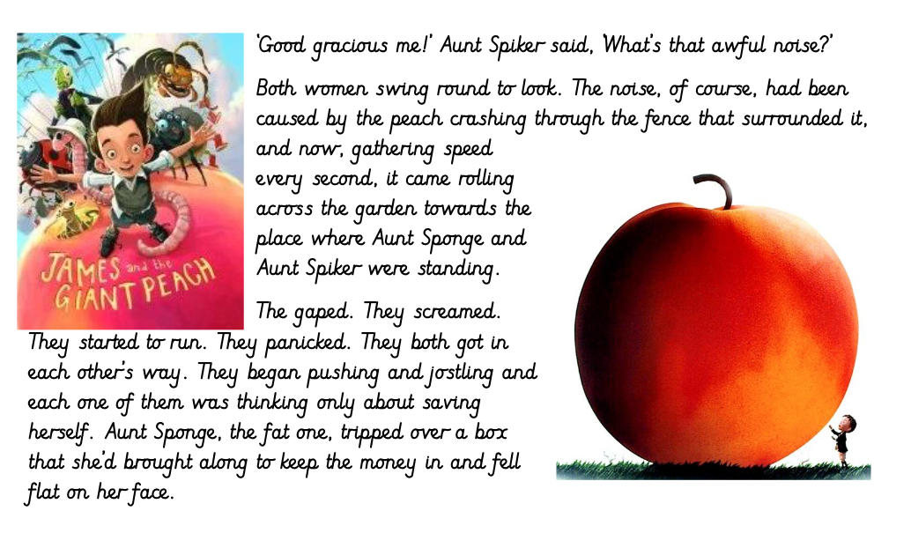
Write the answers in full sentences:

1.What did the peach crash through?

2.What was the peach rolling towards?

3.Write 3 things that the Aunts did when they saw the peach rolling.

4.Which Aunt tripped over a box?

5.What had the Aunt brought the box along for?

6.What did Aunt Sponge fall on?

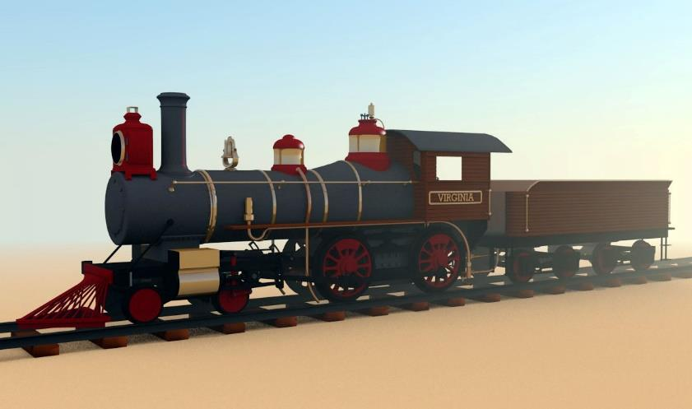
The old railway yard.
Jack was scared. He was walking through an abandoned railway station on his way home. He came this way because it was a lot quicker but he was regretting his decision. His hairs on his neck were stood up like soldiers in a parade. His heart was racing and his stomach churned. As he paced through the creepy yard he tried to stay under the colossal shadows of the huge, ancient steam trains.
Then something strange happened. A light appeared in one of the driver carriages of the train. Hesitantly, Jack stopped and looked back. He could not see anyone in the driver’s carriage! Jack had a decision to make. His head told him to go back home and get out of their as quickly as possible. His heart told him to go and explore the strange light!
Jack made his decision. He sprinted over to the carriage and heaved the door open. It creaked loudly and some dust dropped onto the floor. Jack started to walk through the old carriage which had rotten floorboards. As he got to the old fashioned handle that led into the driver’s compartment, he paused for a moment. He took a deep breath and opened the door.
The air was still. The smell was dusty. The light flickered. Flick. Flick. Flick. But nobody was there. All of a sudden a defeating clank sounded. Jack looked out of the window and saw a tree move sideways. Then Jack had a realisation! It wasn’t the tree moving, it was Jack. It was the
train! The train was slowly winding
down the track. Steam started to chug.
Faster the train went. Faster and faster!
“How can this be?” whispered Jack to himself in amazement! He was sure he was the only person on the train.
- What signs are there that show us Jack was scared?
- Look at paragraph One. It tells us Jack tried to stay under the shadows of the
- train. Why do you think he tried to do this?
- What two words in the first paragraph tell us the trains are big?
- What word in paragraph 2 tells us Jack was uncomfortable?
- Draw and fill in a thought bubble about how Jack might have been feeling at the end of Paragraph 2. Use as much detail as you can.
- There are clues in the text that tell us the steam trains were old. Can you spot them all?
- Why do you think Jack paused before opening the door to the driver’s compartment?

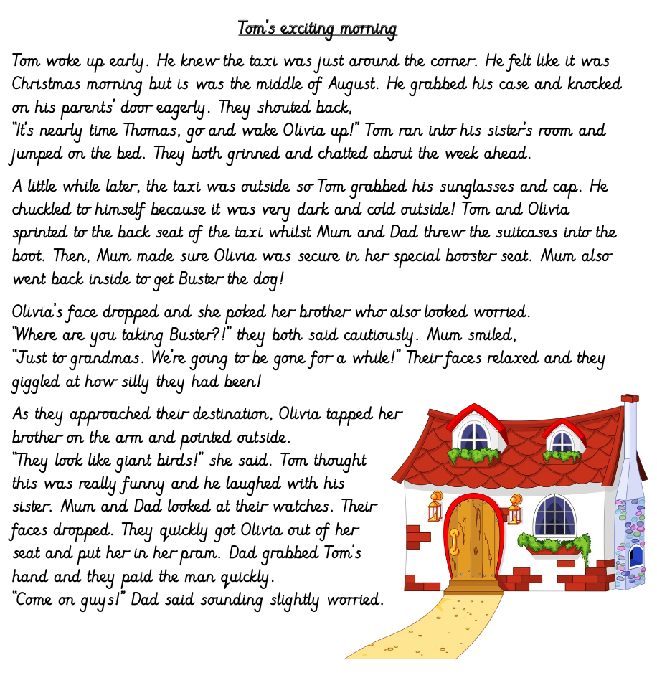
1.How do we know Tom felt excited in Paragraph One? Try and find all the clues.
2.Why do you think Tom chuckled to himself when he went outsidein Paragraph Two?
3.Where do you think Tom is going? Explain why you think this
4.Pretend you are Tom. Write down how you are feeling and what you are thinking as you travel in the taxi
5.Why has Tom packed sunglasses?
6.Why do you think Olivia and Tom were worried when Mum went back into the house to get Buster?
7.What do you think Olivia was pointing to when she said “they look like giant birds!”?
8.What do you think happened when Mum and Dad looked at their watches in paragraph four
9.Pretend you are Dad at the end of the passage. Write a few sentences explaining your thoughts and feelings

Grammar

Common noun = person, place or thing that doesn’t need a capital letter e.g. man, shop, game, book, river.
Proper noun = person, place or name of something that starts with a capital letter e.g. Millie, Oxton, Europa Swimming Pool, River Dee.
Adjective = describing word
Verb = doing word (often ends in ‘ing’)
Task one
Find all of the common nouns and circle all of the proper nouns in each sentence.
- Henry plays games on his computer.
- Mr Fan runs in the park every Sunday.
- Caroline lives in an apartment in Caston St.
- Dr Flood is flying on a plane to Norway.
- Neena’s birthday is in March.
- Fluffy likes playing catch in Victoria Park.
- Did you see William at the party on Saturday?
- Gerrard scored a goal for Liverpool on Tuesday night.
- New Brighton was flooded because of the heavy rain.
- Quinn saw Venus through her telescope.

Task two
Find the adjectives in these sentences:
- The little man carried the heavy box across the wide street.
- The red house stood at the bottom of the deep valley.
- The narrow road was long and the children were tired.
- The log burned brightly in the old fireplace.
- The young lady sat down on the soft, green cushion.
- The busy bee flew to the bright flowers to gather honey.

Task three
Write 10 verbs

Common noun = person, place or thing that doesn’t need a capital letter e.g. woman, sweet, tablet, city.
Proper noun = person, place or name of something that starts with a capital letter e.g. Bob, Dr Doolittle, IPad, Liverpool.
Adjective = describing word
Verb = doing word (often ends in ‘ing’)
Task one
Next to each common noun – write a proper noun.
Man___________________
Woman___________________
Mountain___________________
Building___________________
Cat/Dog___________________
Football team___________________
Tablet___________________

Task two
Use a thesaurus and write next to each adjective two more.
e.g. PrettyBeautifulStunning
Tall___________________________
Angry___________________________
Shy___________________________
Chubby___________________________
Kind___________________________

Task three
Add a verb to complete these sentences.
- I went to the swimming pool and s_________ 20 lengths.
- In netball I p_________ the ball to my team mates.
- When I play football I d______ in-between my opponents.
- I went to the library and saw a lot of children r_______ books.
- On Thursdays I enjoy w_________ the lava lamp bubble.
- On Sports’ Day I r______ as fast as I can.
- The doctor w________ a prescription.
- Mrs Ashdown b___________ a ticket to see Beyonce.
- Millie likes to b________ raspberries.
- When I go to watch a basketball game I c________ loudly for my team.

Art
Drawing a self-portrait!
Step by step guide to drawing your own self-portrait…
When you’re finished why don’t you add a background to your picture that represents you and the things that make you special!
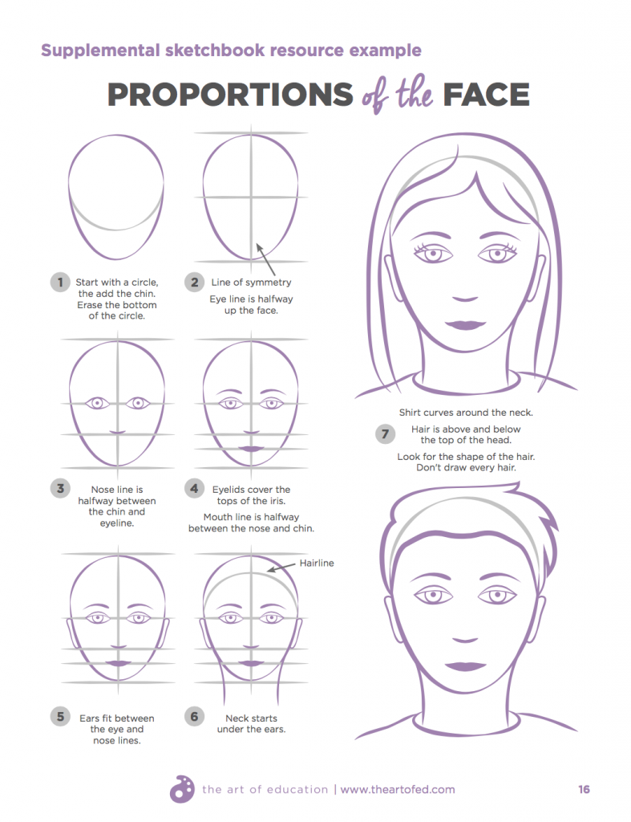
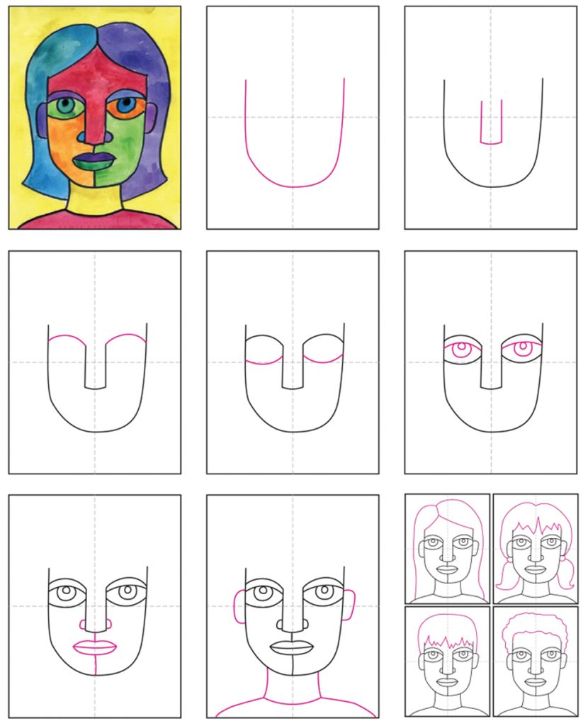
Maybe you could try to draw an abstract portrait like Picasso using different colours and shapes…
Topic- Community Café!
Create your own smoothie.
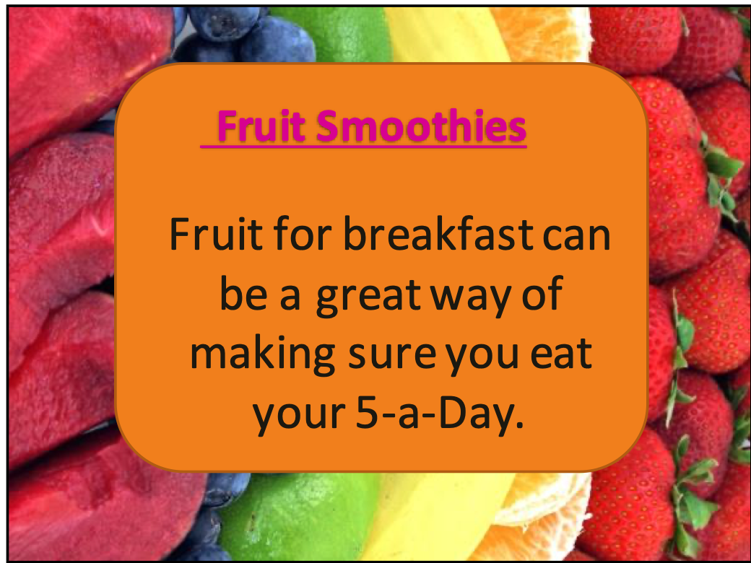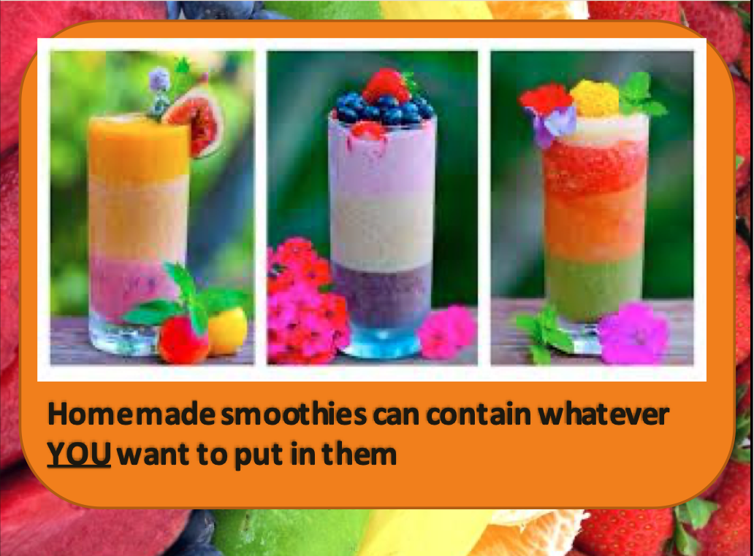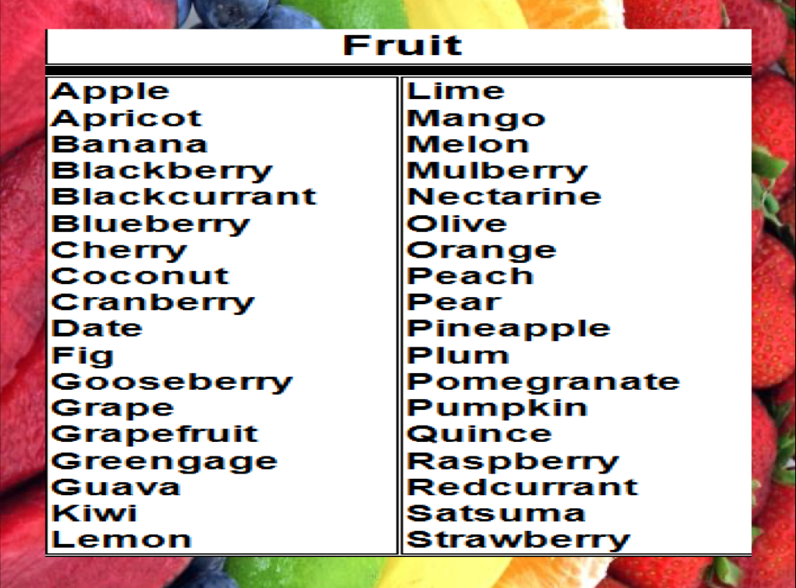
Research.

You are going to design your own smoothie! Before you design your smoothie, you need to do some research and find out what people like in their smoothies.
Below are some questions you can ask to help you plan the perfect smoothie 😊

- Have you ever tried a smoothie?
- Did you enjoy it?
- How often would you drink a smoothie?
- When would you drink your smoothie? breakfast/lunch/dinner/snack?
- Wy would you drink a smoothie? Taste/healthy option/instead of a meal etc
- Name three of your favourite fruits.
- What is the most important smoothie quality?
- Low in calories
- Taste
- Variety of flavours
- Consistency

- What type of consistency do you like your smoothie to be?
- Smooth
- Lumpy
- Thick
- Watery

Name of my smoothie | List of ingredients | Package design

Science
Have a look in your garden and see what insects or birds you can find. Sketch what you find and research some facts. Record them on your fact file.

