**Personal, Social, Emotional Development:**

* We will have a big emphasise on this area of learning in the first half term. The children will be learning to make friends with each other and develop good relationships and take turns in play.
* We will focus on encouraging children to share their ideas through speech within taught sessions and independent play.

**Communication and Language:**

* We will be introducing our class expectations of good looking listening and talking. Ensuring children listen to each other when talking.
* This half term we will be heavily focussing on the children’s language encouraging lots of speech during our learning and through their play.

**Physical Development:**

* Fine motor skills such as writing and drawing will be practiced on a daily basis.
* The children will be encouraged to take responsibility for their toileting and hand washing.
* The children will have a 45 minute PE session each week to improvement their range of movement and strength.

**Literacy:**

* We will be starting a new phonics scheme of ‘Read Write Inc’ 4 days a week.
* Our marvellous me theme will be explored through a variety of different books such as: Funny Bones by Janet Ahlberg, Big! ByTim Hopgood, Blue and Bertie by Kristyna Litten, and also some fiction books about the dentist and opticians
* Children will be encouraged to write their name on all their work.

**Mathematics:**

* We have a daily maths lesson with our maths mascot, Puzzle the squirrel.
* Counting skills will be developed throughout each day, where we will encourage children to count aloud varying amounts and recognise numbers on a number line.
* We will be exploring one more/ less working with numbers up to 10 and higher using a variety of counting objects

F2 Marvellous Me Topic Web

There are 7 Key Areas of Learning and Development in the Early Years Curriculum. We always teach through a cross curricular approach and so these are just a few examples of what we will be doing over the coming weeks.

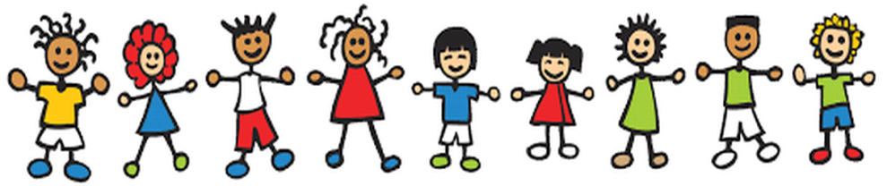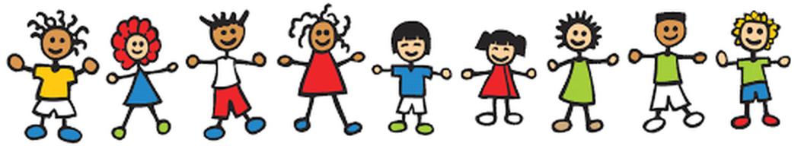

**The World:**

* We will be talking about ourselves and our family and friends, remembering exciting and important occasions we share with them.
* We will be learning about our bodies and teeth and how we change as we grow, as well as how to look after ourselves.

**Expressive Art and Design:**

* We will be doing lots of singing in the classroom, in our music sessions as well as our mathematics and daily learning inputs.
* Children will have the opportunity to be expand their imagination in both our home corner and role play area, of which the theme changes regularly.