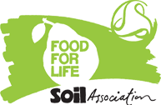
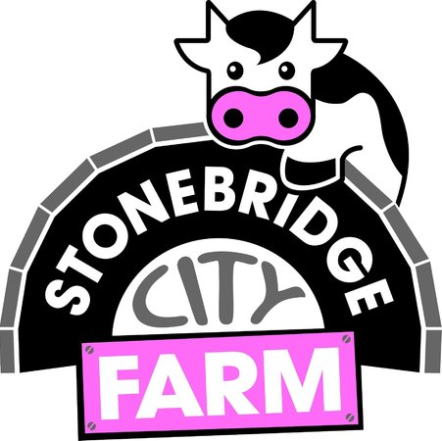
Food for Life trip to Stonebridge City Farm-18.5.16
Today our pupil food group had the opportunity to go and visit our local farm in St Anns. We got on the tram and it took us into the heart of the city where hidden amongst the tall buildings was a farm! This farm inspired us to think about all the things we can grow in our school, we have made plans to add rhubarb, beans, strawberries and garlic to our gardens. We also enjoyed looking at the animals and we had some great discussions over how the animals are looked after and how they help the farm to keep going.
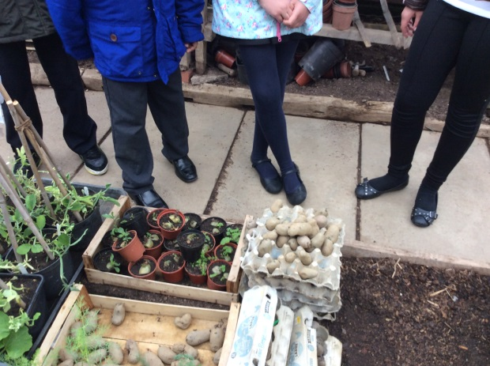
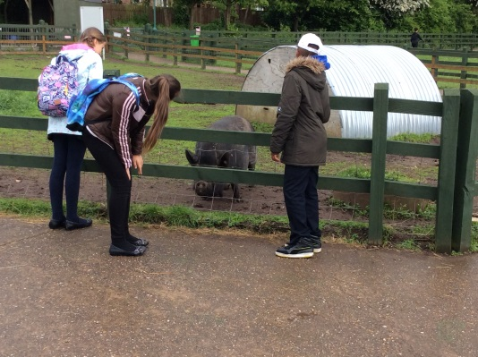
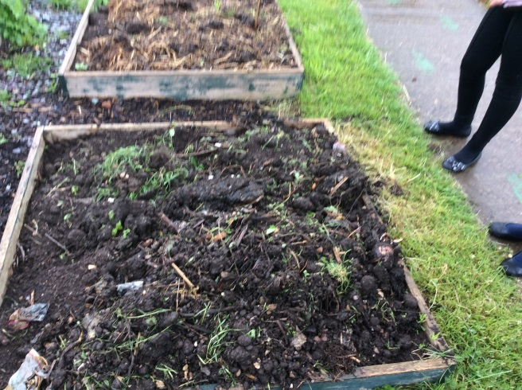
We will be heading back again to Stonebridge for future inspiration!

