Rushcliffe Country Park
We went on a field trip to Rushcliffe Country Park. We went on a ladybird walk, fed the ducks and fish, had a sensory trail, created observational drawings of deciduous and evergreen trees and even had time to play on the park.
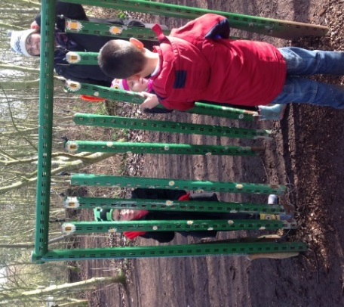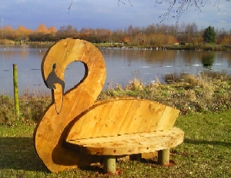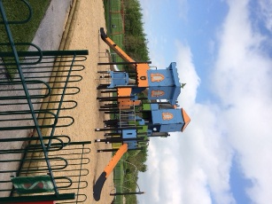
We made sure to try everything on the sensory trail and we had lots of fun.
The play area had so much to offer we could have spent all day there.
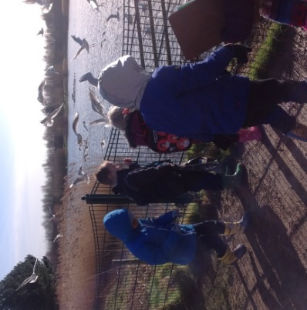
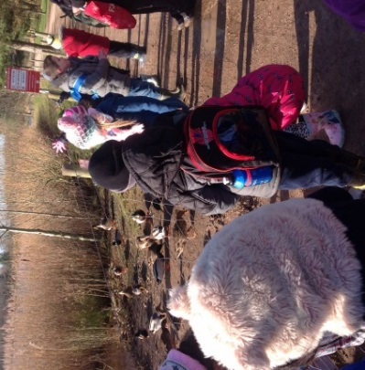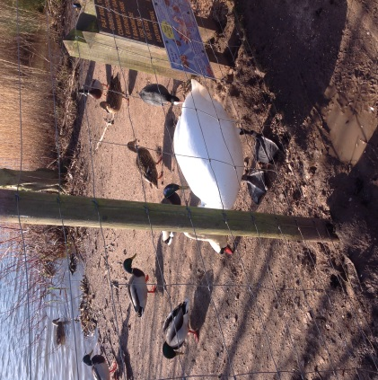
When we fed the birds, we saw lots of different types including swans.

